**Data Structure And Algorithm**

**Data Structure:** Data structures are divided into two types.

* Linear Data Structures
  + Arrays
  + List (Linked List)
    - Singly linked list
    - Circular linked lists
    - Doubly linked list
  + Stack (LIFO)
    - Stack using Array
    - Stack using LinkedList
  + Queue (FIFO)
    - Queue using Array
    - Queue using LinkedList
    - Circular Queue
    - Double Ended Queue
* Non - Linear Data Structures
  + Tree
    - Binary Trees
    - Binary Search Trees
  + Graph
  + Dictionaries
  + Heaps
    - Min Heap
    - Mix Heap
  + Tries, Etc.,
* Hash-Table

Time complexity show as:

O(1) **<** O(logn) **<** O(n) **<** O(n logn) **<** O(n^2) **<** O(2^n) **<** O(n!)

**------------------------------------ Some Algorithm Pattern ------------------------------------------**

**Two Pointer Technique**

**Sliding Window**

A sliding window is a sublist or subarray that runs over an underlying data structure. The data structure is iterable and ordered, such as an array or a string. At a high level, you can think of it as a subset of the two pointers method. It normally encompasses searching for a longest, shortest or optimal sequence that satisfies a given condition.

**------------------------------------------- Data Structure -------------------------------------------**

**Array**

An array is a sequential collection of elements of same data type and stores data elements in a continuous memory location. Each element of an array can be accessed by using *arr[index]*.

**Stack**

Stacks are dynamic data structures that follow the **Last In First Out (LIFO)** principle. The last item to be inserted into a stack is the first one to be deleted from it.

Stacks have restrictions on the insertion and deletion of elements. Elements can be inserted or deleted only from one end of the stack i.e. from the **top**. The element at the top is called the **top** element. The operations of inserting and deleting elements are called **push()** and **pop()** respectively.

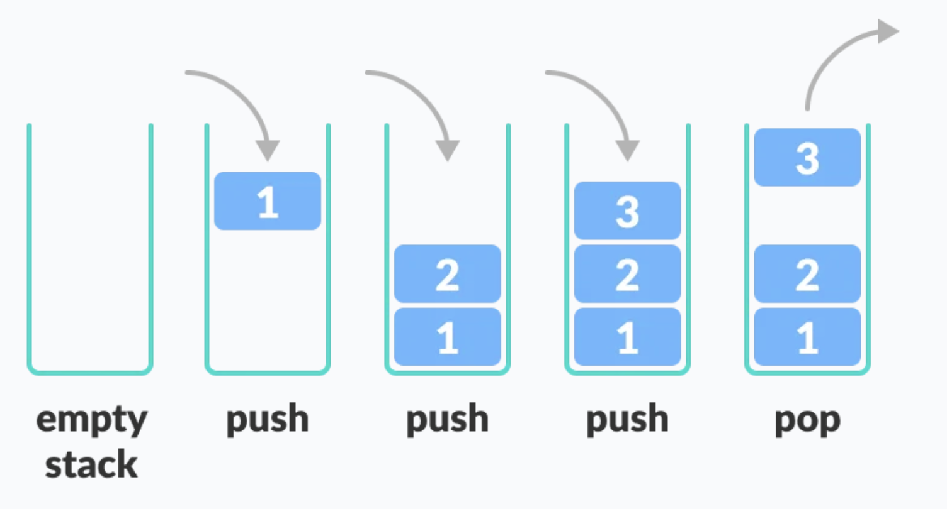

Features of stacks:

* Dynamic data structures
* Do not have a fixed size
* Do not consume a fixed amount of memory
* Size of stack changes with each **push()** and **pop()** operation. Each **push()** and **pop()** operation increases and decreases the size of the stack by **1**, respectively.

**Basic Operations of Stack:** There are some basic operations that allow us to perform different actions on a stack.

* **Push:** Add an element to the top of a stack
* **Pop:** Remove an element from the top of a stack
* **IsEmpty:** Check if the stack is empty
* **IsFull:** Check if the stack is full
* **Peek:** Get the value of the top element without removing it

**Working of Stack Data Structure:** The operations work as follows:

1. A pointer called **TOP** is used to keep track of the top element in the stack.
2. When initializing the stack, we set its value to -1 so that we can check if the stack is empty by comparing **TOP == -1**.
3. On pushing an element, we increase the value of **TOP** and place the new element in the position pointed to by **TOP**.
4. On popping an element, we return the element pointed to by **TOP** and reduce its value.
5. Before pushing, we check if the stack is already full
6. Before popping, we check if the stack is already empty

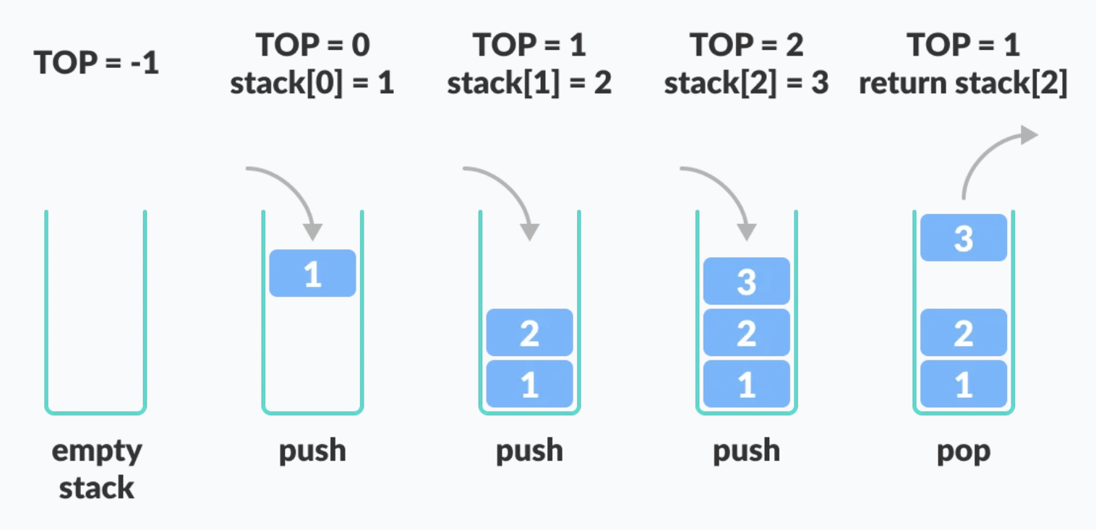

**Stack Time Complexity**

For the array-based implementation of a stack, the **push and pop operations take constant time, i.e. O(1).**

**Queues**

Queues are data structures that follow the **First In First Out (FIFO**) i.e. the first element that is added to the queue is the first one to be removed.

Elements are always added to the back and removed from the front. Think of it as a line of people waiting for a bus. The person who is at the beginning of the line is the first one to enter the bus.

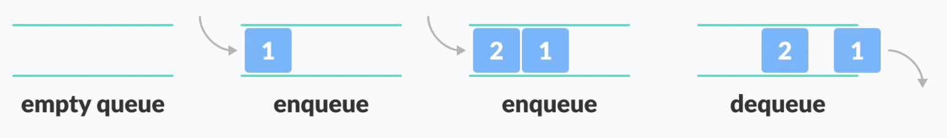

**Enqueue:** If the queue is not full, this function adds an element to the back of the queue, else it prints “**OverFlow**”.

**Dequeue:** If the queue is not empty, this function removes the element from the front of the queue, else it prints “**UnderFlow**”.

**Basic Operations of Queue:** A queue is an object (an abstract data structure - ADT) that allows the following operations:

* **Enqueue**: Add an element to the end of the queue
* **Dequeue**: Remove an element from the front of the queue
* **IsEmpty**: Check if the queue is empty
* **IsFull**: Check if the queue is full
* **Peek**: Get the value of the front of the queue without removing it

**Working of Queue:** Queue operations work as follows:

* two pointers **FRONT** and **REAR**
* **FRONT** track the first element of the queue
* **REAR** track the last element of the queue
* initially, set value of **FRONT** and **REAR** to -1

**Enqueue Operation**

* check if the queue is full
* for the first element, set the value of **FRONT** to 0
* increase the **REAR** index by 1
* add the new element in the position pointed to by REAR

**Dequeue Operation**

* check if the queue is empty
* return the value pointed by **FRONT**
* increase the **FRONT** index by 1
* for the last element, reset the values of **FRONT** and **REAR** to -1

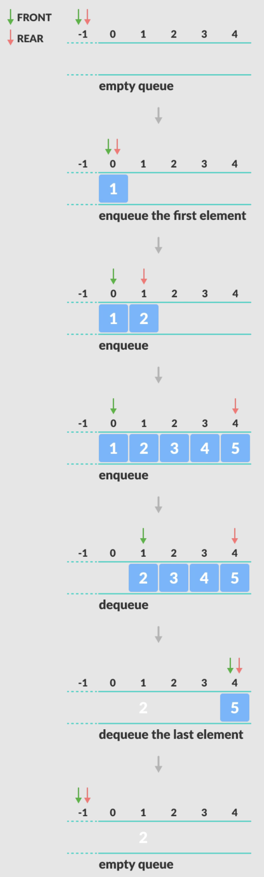

**Queue Time Complexity**

The complexity of **enqueue and dequeue operations** in a queue using an array **is O(1)**

**Limitations of Queue**

As you can see in the image below, after a bit of enqueuing and dequeuing, the size of the queue has been reduced.

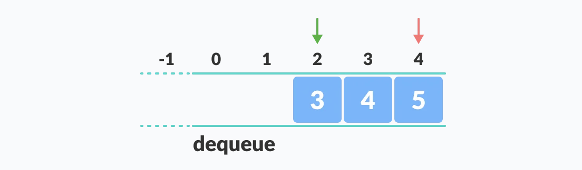

And we can only add indexes 0 and 1 only when the queue is reset (when all the elements have been dequeued).

After **REAR** reaches the last index, if we can store extra elements in the empty spaces (0 and 1), we can make use of the empty spaces. This is implemented by a modified queue called **the circular queue**.

**Types of Queues:**

* Simple Queue
* Circular Queue
* Priority Queue
* Double Ended Queue

**Simple Queue**

In a simple queue, insertion takes place at the rear and removal occurs at the front. It strictly follows the FIFO (First in First out) rule.



**Circular Queue**

A circular queue is the extended version of a regular queue where the last element is connected to the first element. Thus forming a circle-like structure.

The circular queue solves the major limitation of the normal queue. In a normal queue, after a bit of insertion and deletion, there will be non-usable empty space.

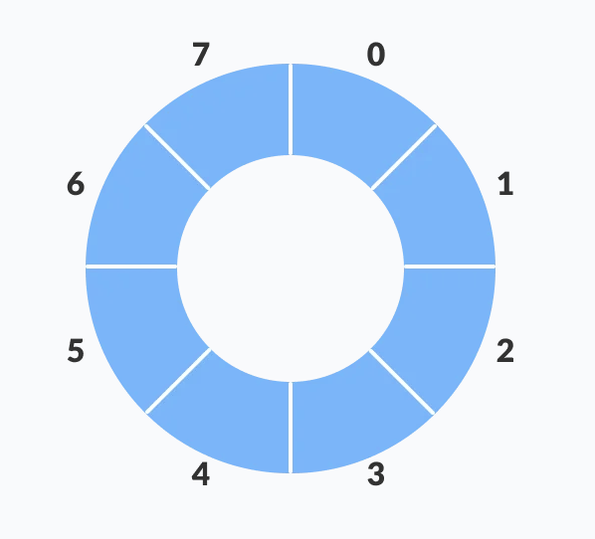 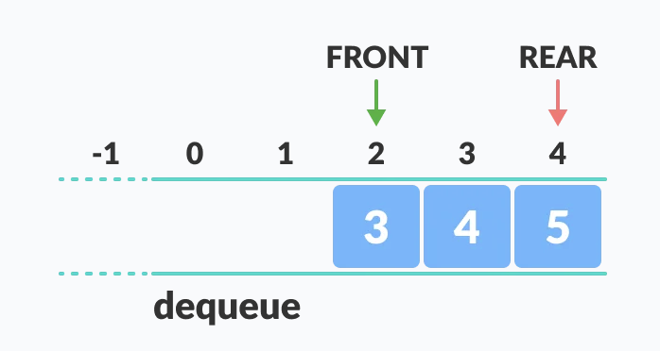

Here, indexes 0 and 1 can only be used after resetting the queue (deletion of all elements). This reduces the actual size of the queue.

**Circular Queue Operations:** The circular queue work as follows:

* two pointers FRONT and REAR
* FRONT track the first element of the queue
* REAR track the last elements of the queue
* initially, set value of FRONT and REAR to -1

**1. Enqueue Operation**

* check if the queue is full
* for the first element, set value of FRONT to 0
* circularly increase the REAR index by 1 (i.e. if the rear reaches the end, next it would be at the start of the queue)
* add the new element in the position pointed to by REAR

**2. Dequeue Operation**

* check if the queue is empty
* return the value pointed by FRONT
* circularly increase the FRONT index by 1
* for the last element, reset the values of FRONT and REAR to -1

However, the check for full queue has a new additional case:

* Case 1: FRONT = 0 && REAR == SIZE - 1
* Case 2: FRONT = REAR + 1

The second case happens when REAR starts from 0 due to circular increment and when its value is just 1 less than FRONT, the queue is full.

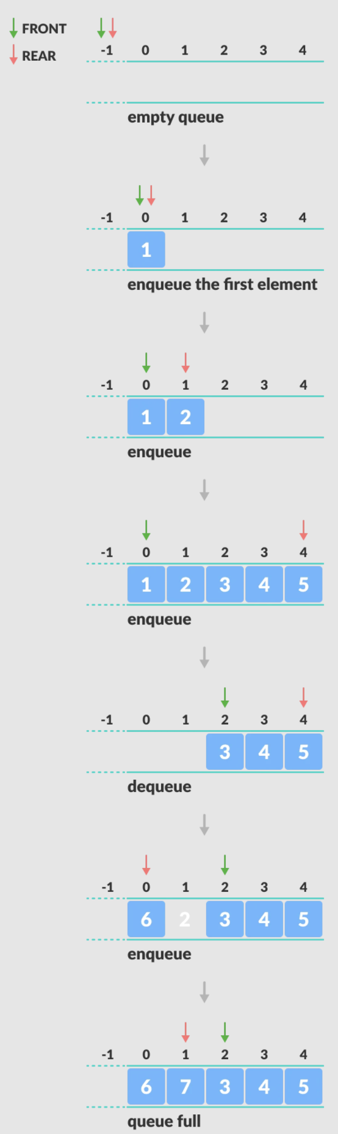

**Circular Queue Time complexity**

The complexity of the **enqueue and dequeue operations of a circular queue is O(1)** for (array implementations).

**Priority Queue**

A priority queue is a **special type of queue** in which each element is associated with a **priority value**. And, elements are served on the basis of their priority. That is, higher priority elements are served first.

However, if elements with the same priority occur, they are served according to their order in the queue.

**Difference between Priority Queue and Normal Queue**

In a queue, the **first-in-first-out** rule is implemented whereas, in a priority queue, the values are removed **on the basis of priority**. The element with the highest priority is removed first.

**Implementation of Priority Queue**

Priority queue can be implemented using an array, a linked list, a heap data structure, or a binary search tree. Among these data structures, heap data structure provides an efficient implementation of priority queues.

Hence, we will be using the heap data structure to implement the priority queue in this tutorial. A max-heap is implement is in the following operations. If you want to learn more about it, please visit max-heap and mean-heap.

**Deque (Double Ended Queue)**

Deque or Double Ended Queue is a type of queue in which **insertion and removal of elements** can either be performed **from the front or the rear**. Thus, it does not follow FIFO rule (First In First Out).

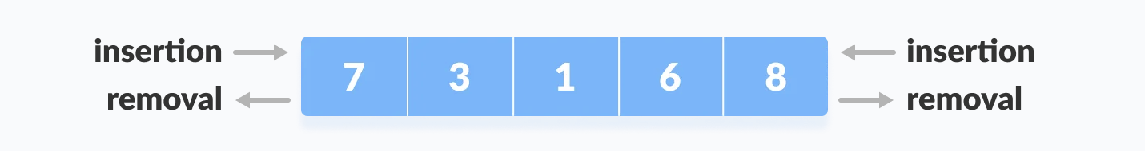

**Types of Deque**

* **Input Restricted Deque**

In this deque, input is restricted at a single end but allows deletion at both the ends.

* **Output Restricted Deque**

In this deque, output is restricted at a single end but allows insertion at both the ends.

**Operations on a Deque**

Below is the circular array implementation of deque. In a circular array, if the array is full, we start from the beginning.

But in a linear array implementation, if the array is full, no more elements can be inserted. In each of the operations below, if the array is full, "overflow message" is thrown.

Before performing the following operations, these steps are followed.

1. Take an array (deque) of size n.
2. Set two pointers at the first position and set front = -1 and rear = 0.

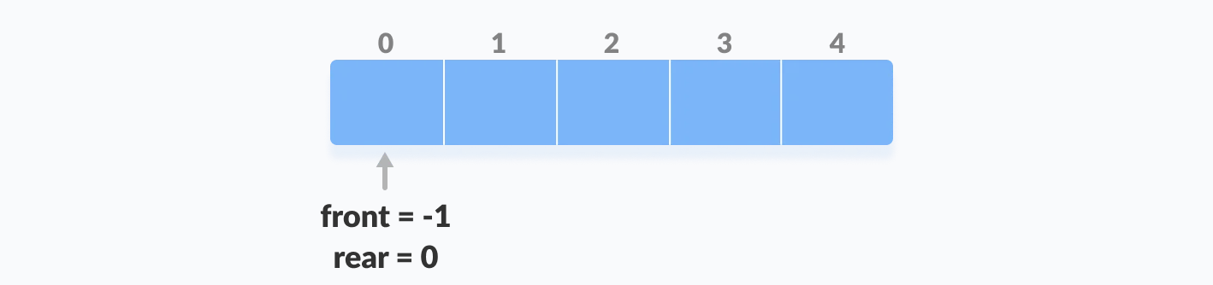

**1. Insert at the Front:** This operation adds an element at the front.

1. Check the position of front
2. If front < 1, reinitialize front = n-1 (last index)
3. Else, decrease front by 1
4. Add the new key 5 into array[front]

**2. Insert at the Rear:** This operation adds an element to the rear.

1. Check if the array is full
2. If the deque is full, reinitialize rear = 0.
3. Else, increase rear by 1
4. Add the new key 5 into array[rear]

**3. Delete from the Front:** The operation deletes an element from the front.

1. Check if the deque is empty.
2. If the deque is empty (i.e. front = -1), deletion cannot be performed (underflow condition).
3. If the deque has only one element (i.e. front = rear), set front = -1 and rear = -1.
4. Else if front is at the end (i.e. front = n - 1), set go to the front front = 0.
5. Else, front = front + 1

**4. Delete from the Rear:** This operation deletes an element from the rear.

1. Check if the deque is empty
2. If the deque is empty (i.e. front = -1), deletion cannot be performed (underflow condition).
3. If the deque has only one element (i.e. front = rear), set front = -1 and rear = -1, else follow the steps below.
4. If rear is at the front (i.e. rear = 0), set go to the front rear = n - 1.
5. Else, rear = rear - 1

**5. Check Empty:** This operation checks if the deque is empty. If front = -1, the deque is empty.

6**. Check Full:** This operation checks if the deque is full. If front = 0 and rear = n - 1 OR front = rear + 1, the deque is full.

**Deque Time Complexity:**

The time complexity of all the above operations is constant i.e. O(1)

**Linked List**

A linked list is a linear data structure that includes a series of connected nodes. Here, each node store the **data** and the **address** of the next node. For example,



Linked lists can be of multiple types: **singly , doubly, and circular linked list.**

**Note:** You might have played the game Treasure Hunt, where each clue includes the information about the next clue. That is how the linked list operates.

**Linked List Time Complexity:**

**Search -> O(n),**

**Insert and Delete -> O(1)**

**Space Complexity: O(n)**

**Hash Table**

The Hash table data structure stores elements in key-value pairs where

* **Key** - unique integer that is used for indexing the values
* **Value** - data that are associated with keys.

**Hashing (Hash Function)**

In a hash table, a new index is processed using the keys. And, the element corresponding to that key is stored in the index. This process is called **hashing**.

Let **k be a key** **and h(x) be a hash function**.

Here, h(k) will give us a new index to store the element linked with k.

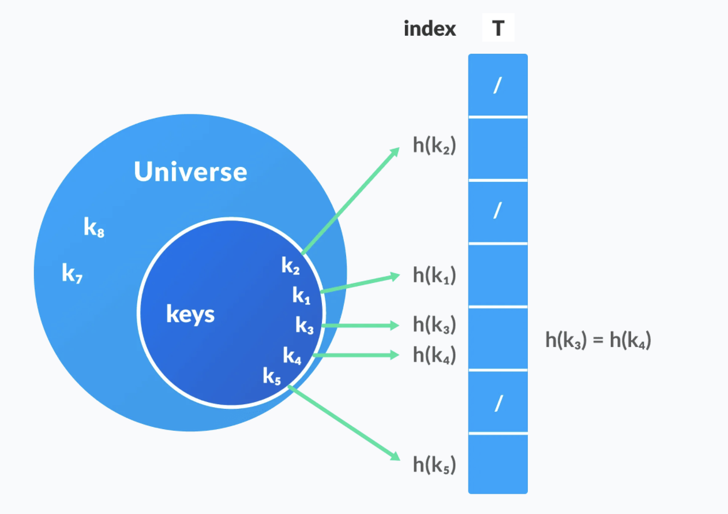

**Hash Collision**

When the hash function generates the **same index for multiple keys**, there will be a conflict (what value to be stored in that index). This is called a **hash collision**.

We can resolve the hash collision using one of the following techniques.

* Collision resolution by chaining
* Open Addressing: Linear/Quadratic Probing and Double Hashing

**1. Collision resolution by chaining**

In chaining, if a hash function produces the same index for multiple elements, these elements are stored in the same index by using a doubly-linked list.

If j is the slot for multiple elements, it contains a pointer to the head of the list of elements. If no element is present, j contains NIL.

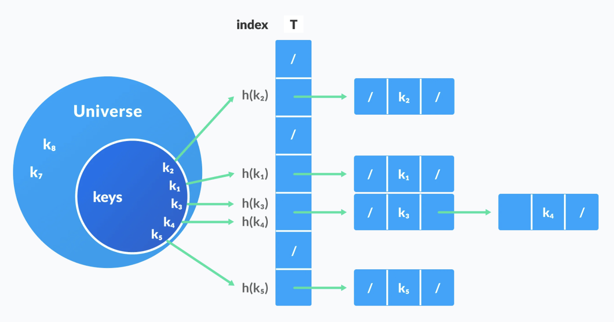

**2. Open Addressing**

Unlike chaining, open addressing doesn't store multiple elements into the same slot. Here, each slot is either filled with a single key or left NIL.

Different techniques used in open addressing are:

**i). Linear Probing :** In linear probing, collision is resolved by checking the next slot.

h(k, i) = (h′(k) + i) mod m

where

* *i = {0, 1, ….}*
* *h'(k)* is a new hash function

If a collision occurs at *h(k, 0),* then *h(k, 1)* is checked. In this way, the value of *i* is incremented linearly.

The problem with linear probing is that a cluster of adjacent slots is filled. When inserting a new element, the entire cluster must be traversed. This adds to the time required to perform operations on the hash table.

**ii. Quadratic Probing:** It works similar to linear probing but the spacing between the slots is increased (greater than one) by using the following relation.

h(k, i) = (h′(k) + c1i + c2i2) mod m

where,

* c1 and c2 are positive auxiliary constants,
* i = {0, 1, ….}

**iii. Double hashing:** If a collision occurs after applying a hash function h(k), then another hash function is calculated for finding the next slot.

h(k, i) = (h1(k) + ih2(k)) mod m

**Good Hash Functions**

A good hash function may not prevent the collisions completely however it can reduce the number of collisions.

Here, we will look into different methods to find a good hash function

**1. Division Method :** If k is a key and m is the size of the hash table, the hash function h() is calculated as:

h(k) = k mod m

For example, If the size of a hash table is 10 and k = 112 then h(k) = 112 mod 10 = 2. The value of m must not be the powers of 2. This is because the powers of 2 in binary format are 10, 100, 1000, …. When we find k mod m, we will always get the lower order p-bits.

if m = 22, k = 17, then h(k) = 17 mod 22 = 10001 mod 100 = 01

if m = 23, k = 17, then h(k) = 17 mod 22 = 10001 mod 100 = 001

if m = 24, k = 17, then h(k) = 17 mod 22 = 10001 mod 100 = 0001

if m = 2p, then h(k) = p lower bits of m

**2. Multiplication Method**

h(k) = ⌊m(kA mod 1)⌋

where,

* kA mod 1 gives the fractional part kA,
* ⌊ ⌋ gives the floor value
* A is any constant. The value of A lies between 0 and 1. But, an optimal choice will be ≈ (√5-1)/2 suggested by Knuth.

**3. Universal Hashing:** In Universal hashing, the hash function is chosen at random independent of keys.

**Heap Data Structure**

Heap data structure is a **complete binary tree that satisfies the heap property**, where any given node is

* always greater than its child node/s and the key of the **root node is the largest among all other nodes**. This property is also called **max heap property**.
* always smaller than the child node/s and the key of the **root node is the smallest among all other nodes**. This property is also called **min heap property**.

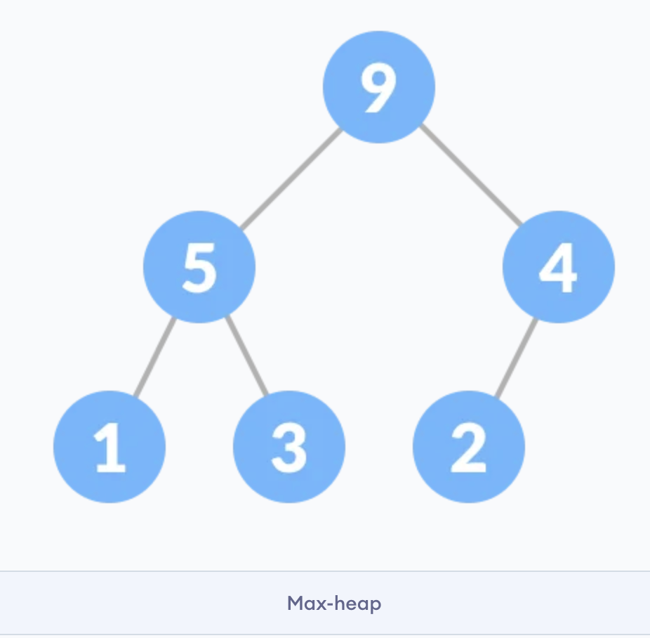 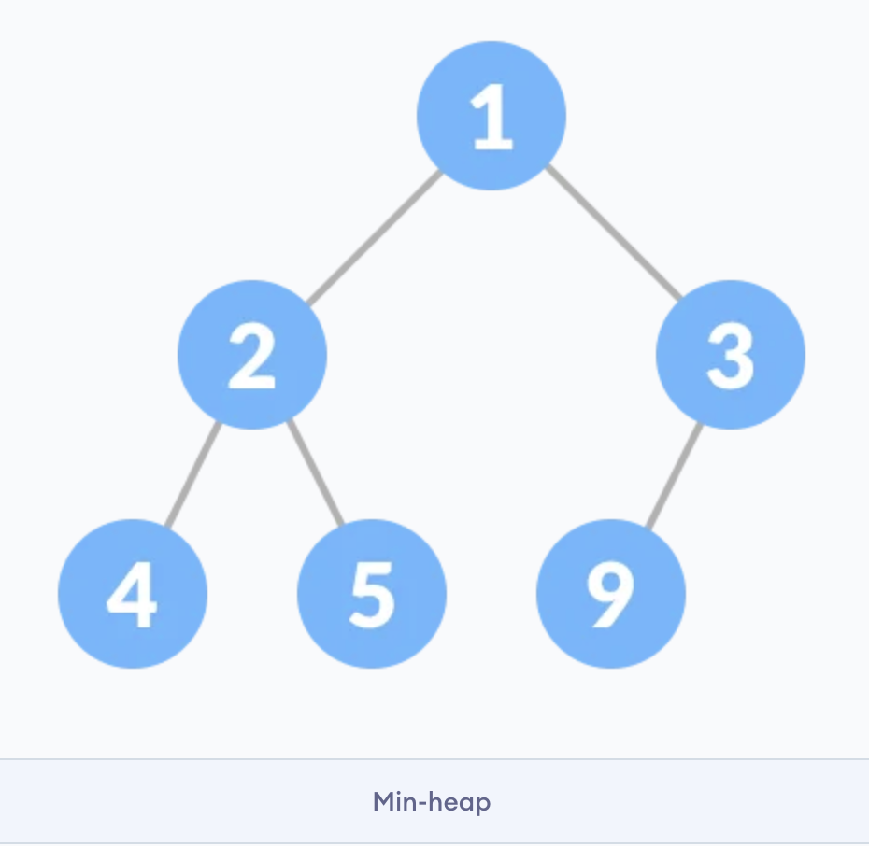

This type of data structure is also called a **binary heap**.

**--------------------------- Tree DSA(Tree Data Structure Algorithm) --------------------------------**

**Why Tree Data Structure?**

Other data structures such as arrays, linked list, stack, and queue are linear data structures that store data sequentially. In order to perform any operation in a linear data structure, the time complexity increases with the increase in the data size. But, it is not acceptable in today's computational world.

Different tree data structures allow quicker and easier access to the data as it is a non-linear data structure.

**Types of Tree**

* **Binary Tree**
* **Binary Search Tree**
* **AVL Tree**
* **B-Tree**

**Tree Applications**

* Binary Search Trees(BSTs) are used to quickly check whether an element is present in a set or not.
* Heap is a kind of tree that is used for heap sort.
* A modified version of a tree called Tries is used in modern routers to store routing information.
* Most popular databases use B-Trees and T-Trees, which are variants of the tree structure
* Compilers use a syntax tree to validate the syntax of every program you write.

**Tree Traversal:** Traversing a tree means visiting every node in the tree.

there can be three types of traversal.

1. inorder,
2. preorder and
3. postorder

**Inorder traversal:** left-root-right

1. First, visit all the nodes in the left subtree
2. Then the root node
3. Visit all the nodes in the right subtree

inorder(root->left)

display(root->data)

inorder(root->right)

**Preorder traversal:** root-left-right

1. Visit root node
2. Visit all the nodes in the left subtree
3. Visit all the nodes in the right subtree

display(root->data)

preorder(root->left)

preorder(root->right)

**Postorder traversal:** left-right-root

1. Visit all the nodes in the left subtree
2. Visit all the nodes in the right subtree
3. Visit the root node

postorder(root->left)

postorder(root->right)

display(root->data)

Commonly-used terminologies

* **Root**: Top node in a tree
* **Child**: Nodes that are next to each other and connected downwards
* **Parent**: Converse notion of child
* **Siblings**: Nodes with the same parent
* **Descendant**: Node reachable by repeated proceeding from parent to child
* **Ancestor**: Node reachable by repeated proceeding from child to parent.
* **Leaf**: Node with no children
* **Internal node**: Node with at least one child
* **External node**: Node with no children

**Types of Binary Tree**

**1. Full Binary Tree:** every parent node/internal node has either two or no children.

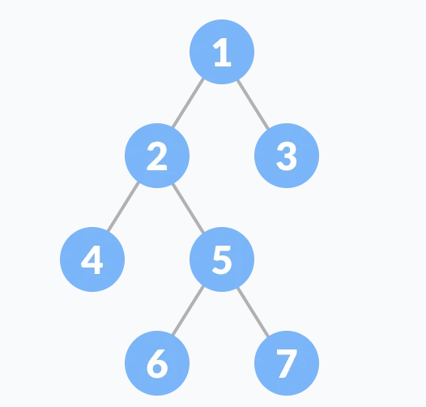

**2. Perfect Binary Tree:** every internal node has exactly two child nodes and all the leaf nodes are at the same level.

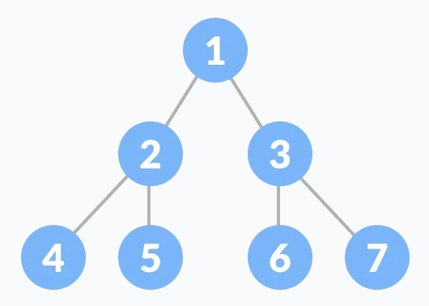

**3. Complete Binary Tree:** just like a full binary tree, but with two major differences

1. Every level must be completely filled
2. All the leaf elements must lean towards the left.
3. The last leaf element might not have a right sibling i.e. a complete binary tree doesn't have to be a full binary tree.

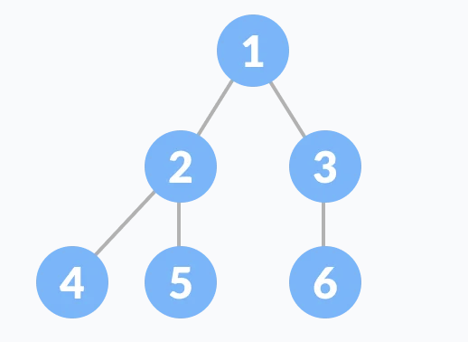

**4. Degenerate or Pathological Tree:** tree having a single child either left or right.

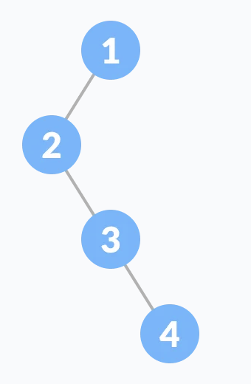

**5. Skewed Binary Tree:** A skewed binary tree is a pathological/degenerate tree in which the tree is either dominated by the left nodes or the right nodes. Thus, there are two types of skewed binary tree: left-skewed binary tree and right-skewed binary tree.

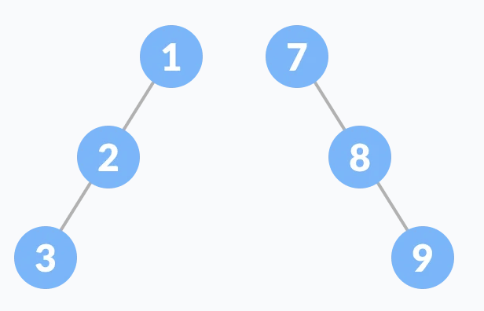

**6. Balanced Binary Tree:** It is a type of binary tree in which the difference between the height of the left and the right subtree for each node is either 0 or 1.

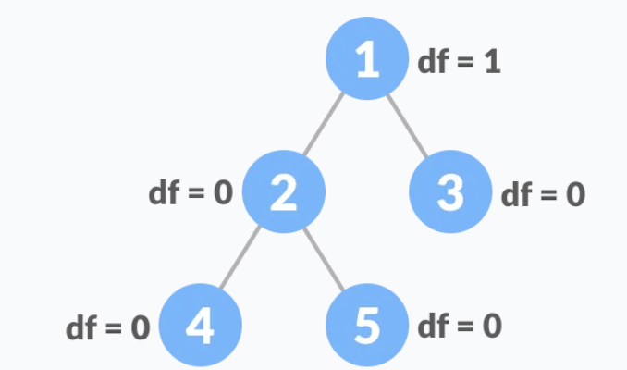

**df =** **(Height of Left Subtree - Height of Right Subtree) or (Height of Right Subtree - Height of Left Subtree)**

**Binary Search Tree or BST**

Binary search tree is a data structure that quickly allows us to maintain a sorted list of numbers.

* It is called a binary tree because each tree node has a maximum of two children.
* It is called a search tree because it can be used to search for the presence of a number in O(log(n)) time.

The **properties** that separate a binary search tree from a regular binary tree is

1. All nodes of **left subtree are less than** the **root node**
2. All nodes of **right subtree are more than** the **root node**
3. **Both subtrees of each node are also BSTs** i.e. they have the above two properties.

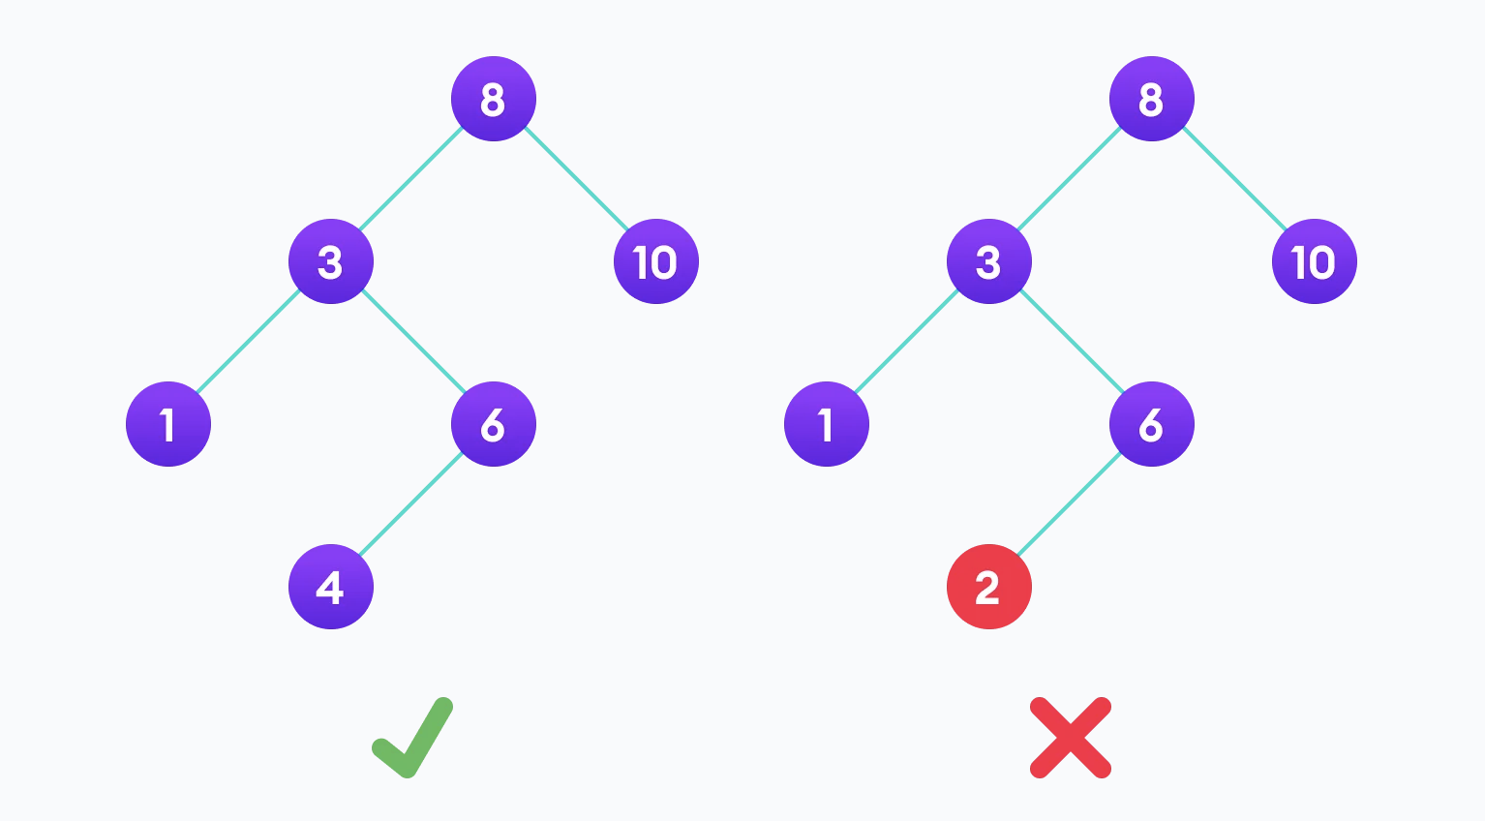

The binary tree on the right isn't a binary search tree because the right subtree of the node "3" contains a value smaller than it.

There are three basic operations that you can perform on a binary search tree:

**Search Operation:**

If root == NULL

return NULL;

If number == root->data

return root->data;

If number < root->data

return search(root->left)

If number > root->data

return search(root->right)

**Insert Operation:**

If node == NULL

return createNode(data)

if (data < node->data)

node->left = insert(node->left, data);

else if (data > node->data)

node->right = insert(node->right, data);

return node;

**Deletion Operation:**

**Case I:** In the first case, the node to be deleted is the leaf node. In such a case, simply delete the node from the tree.

**Case II:** In the second case, the node to be deleted lies has a single child node. In such a case follow the steps below:

1. Replace that node with its child node.
2. Remove the child node from its original position.

**Case III:** In the third case, the node to be deleted has two children. In such a case follow the steps below:

1. Get the inorder successor of that node.
2. Replace the node with the inorder successor.
3. Remove the inorder successor from its original position.

**Binary Search Tree Complexities**

**Search, Insertion and Deletion** take **O(log n)** in **best and average** case but take **O(n)** in **worst case complexity**

**Space Complexity**

The **space complexity** for all the operations is **O(n)**

**AVL Tree**

**AVL tree is a self-balancing binary search tree** in which each node maintains extra information called a **balance factor whose value is either -1, 0 or +1**.

AVL tree got its name after its inventor Georgy Adelson-Velsky and Landis.

**Balance Factor**

Balance factor of a node in an AVL tree is the difference between the height of the left subtree and that of the right subtree of that node.

**Balance Factor = (Height of Left Subtree - Height of Right Subtree) or (Height of Right Subtree - Height of Left Subtree)**

**Note:** The self-balancing property of an avl tree is maintained by the balance factor. The value of balance factor should always be -1, 0 or +1.

An example of a balanced avl tree is:

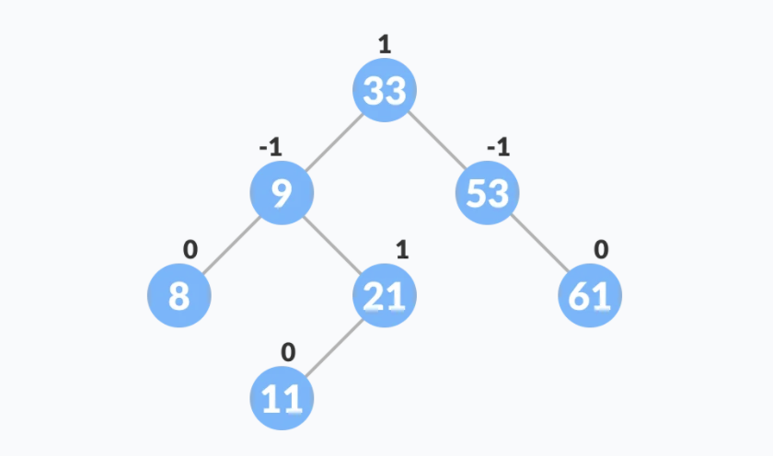

Have to read more about it

_________________________________________________________________________________

_________________________________________________________________________________

_________________________________________________________________________________

_________________________________________________________________________________

_________________________________________________________________________________

_________________________________________________________________________________

**B-tree**

**B-tree** is a special type of self-balancing search tree in which each node can contain **more than one key and can have more than two children**. It is a generalized form of the binary search tree.

It is also known as a **height-balanced m-way tree**.

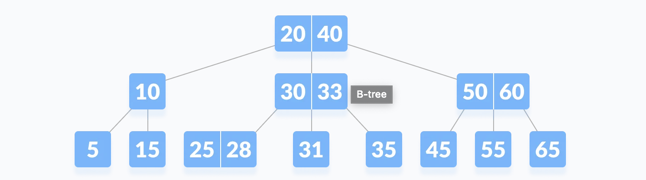

**Why do you need a B-tree data structure?**

The need for B-tree arose with the rise in the need for lesser time in accessing the physical storage media like a hard disk. The secondary storage devices are slower with a larger capacity. There was a need for such types of data structures that minimize the disk accesses.

Other data structures such as a binary search tree, avl tree, red-black tree, etc can store only one key in one node. If you have to store a large number of keys, then the height of such trees becomes very large and the access time increases.

However, B-tree can store many keys in a single node and can have multiple child nodes. This decreases the height significantly allowing faster disk accesses.

Have to read more about it

_________________________________________________________________________________

_________________________________________________________________________________

_________________________________________________________________________________

_________________________________________________________________________________

_________________________________________________________________________________

_________________________________________________________________________________

**B+ Tree**

Have to read more about it

_________________________________________________________________________________

_________________________________________________________________________________

_________________________________________________________________________________

_________________________________________________________________________________

_________________________________________________________________________________

_________________________________________________________________________________

**Red-Black Tree**

Have to read more about it

_________________________________________________________________________________

_________________________________________________________________________________

_________________________________________________________________________________

_________________________________________________________________________________

_________________________________________________________________________________

_________________________________________________________________________________

**------------------------------------------- Graph Base DSA--------------------------------------------**

**Graph Data Stucture**

A graph data structure is a collection of nodes that have data and are connected to other nodes.

Let's try to understand this through an example. On facebook, everything is a node. That includes User, Photo, Album, Event, Group, Page, Comment, Story, Video, Link, Note...anything that has data is a node.

Every relationship is an edge from one node to another. Whether you post a photo, join a group, like a page, etc., a new edge is created for that relationship.

Example of graph data structure

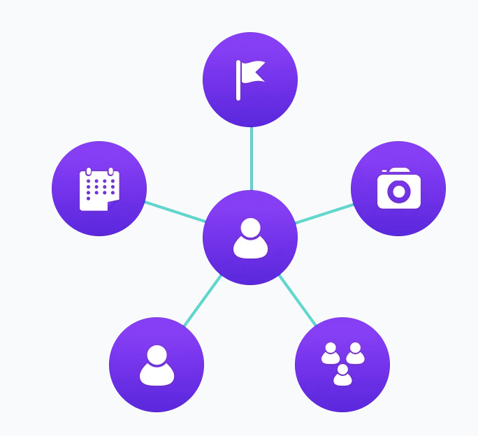

All of facebook is then a collection of these nodes and edges. This is because facebook uses a graph data structure to store its data.

More precisely, a graph is a data structure (V, E) that consists of

* A collection of vertices V
* A collection of edges E, represented as ordered pairs of vertices (u,v)

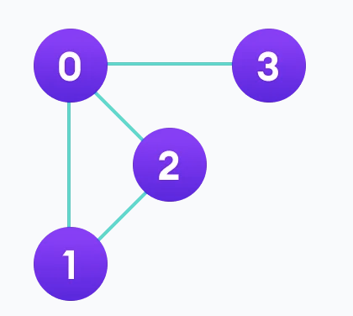

In the graph,

V = {0, 1, 2, 3}

E = {(0,1), (0,2), (0,3), (1,2)}

G = {V, E}

**Graph Terminology**

* **Adjacency:** A vertex is said to be adjacent to another vertex if there is an edge connecting them. Vertices 2 and 3 are not adjacent because there is no edge between them.
* **Path:** A sequence of edges that allows you to go from vertex A to vertex B is called a path. 0-1, 1-2 and 0-2 are paths from vertex 0 to vertex 2.
* **Directed Graph:** A graph in which an edge (u,v) doesn't necessarily mean that there is an edge (v, u) as well. The edges in such a graph are represented by arrows to show the direction of the edge.

**Spanning tree**

A spanning tree is a sub-graph of an undirected connected graph, which includes all the vertices of the graph with a minimum possible number of edges. If a vertex is missed, then it is not a spanning tree.

The edges may or may not have weights assigned to them.

**The total number of spanning trees with n vertices that can be created from a complete graph is equal to n(n-2).**

If we have **n = 4**, the maximum number of possible spanning trees is equal **to 44-2 = 16**. Thus, **16 spanning trees** can be formed from a complete **graph with 4 vertices**.

**Example of a Spanning Tree**

Let's understand the spanning tree with examples below:

Let the original graph be:

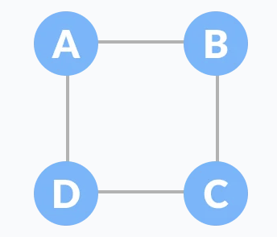

Some of the possible spanning trees that can be created from the above graph are:

|  |  |  |
| --- | --- | --- |
|  |  |  |
|  |  |  |

**Minimum Spanning Tree**

A minimum spanning tree is a spanning tree in which the sum of the weight of the edges is as minimum as possible.

**Example of a Spanning Tree**

Let's understand the above definition with the help of the example below.

The initial graph is:

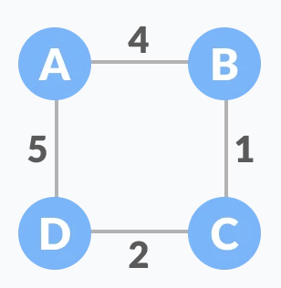

The possible spanning trees from the above graph are:

|  |  |  |  |
| --- | --- | --- | --- |
|  |  |  |  |

The minimum spanning tree from the above spanning trees is:

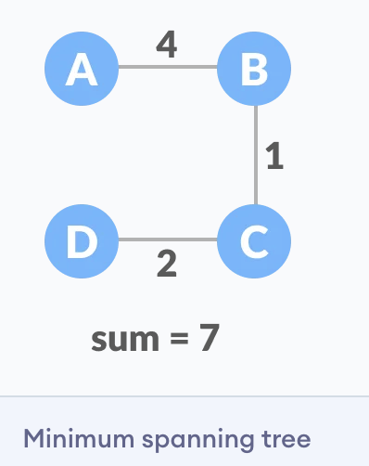

The minimum spanning tree from a graph is found using the following algorithms:

1. **Prim's Algorithm**
2. **Kruskal's Algorithm**

**Strongly Connected Components**

A strongly connected component is the portion of a directed graph in which there is a path from each vertex to another vertex. It is applicable only on a directed graph.

For example:

Let us take the graph below.

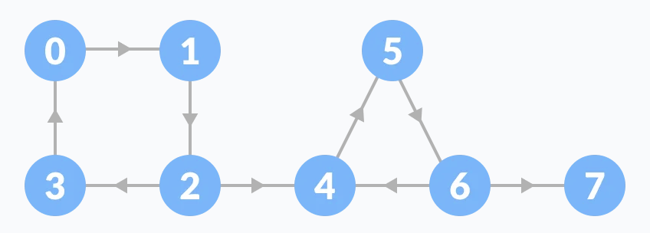

The strongly connected components of the above graph are:

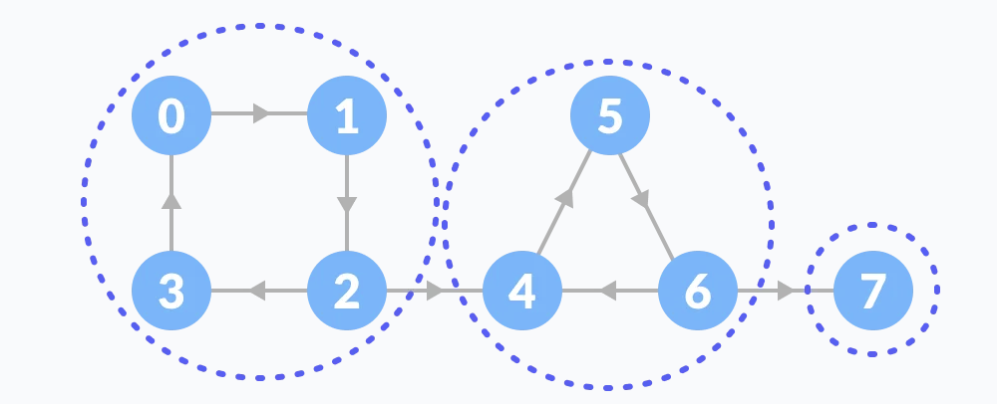

You can observe that in the first strongly connected component, every vertex can reach the other vertex through the directed path.

These components can be found using **Kosaraju's Algorithm.**

**Kosaraju's Algorithm**

Kosaraju's Algorithm is based on the **depth-first search algorithm implemented twice**.

<https://www.programiz.com/dsa/strongly-connected-components>

**Adjacency Matrix**

An adjacency matrix is a way of representing a graph as a **matrix of booleans (0's and 1's).** A finite graph can be represented in the form of a square matrix on a computer, where the boolean value of the matrix indicates if there is a direct path between two vertices.

For example, we have a graph below.

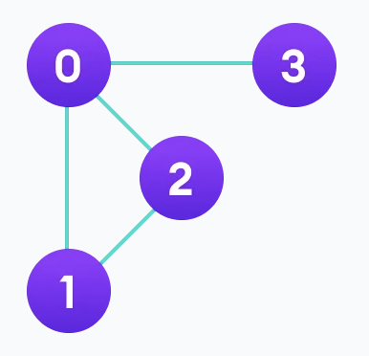

We can represent this graph in matrix form like below.

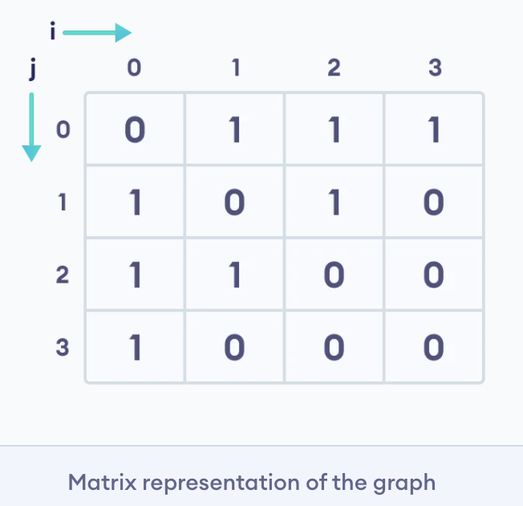

Each cell in the above table/matrix is represented as *Aij*, where *i* and *j* are vertices. The value of *Aij* is either 1 or 0 depending on whether there is an edge from vertex *i* to vertex *j*.

If there is a path from i to j, then the value of *Aij* is 1 otherwise its 0. For instance, there is a path from vertex 1 to vertex 2, so *A12* is 1 and there is no path from vertex 1 to 3, so *A13* is 0.

In case of undirected graphs, the matrix is symmetric about the diagonal because of every edge *(i,j)*, there is also an edge *(j,i)*.

**Pros of Adjacency Matrix**

* The basic operations like adding an edge, removing an edge and checking whether there is an edge from vertex i to vertex j are extremely time efficient, constant time operations.
* If the graph is dense and the number of edges is large, an adjacency matrix should be the first choice. Even if the graph and the adjacency matrix is sparse, we can represent it using data structures for sparse matrices.

**Cons of Adjacency Matrix**

* The biggest advantage however, comes from the use of matrices. The recent advances in hardware enable us to perform even expensive matrix operations on the GPU.
* By performing operations on the adjacent matrix, we can get important insights into the nature of the graph and the relationship between its vertices.

**Adjacency List**

An adjacency list represents a graph as an array of linked lists. The index of the array represents a vertex and each element in its linked list represents the other vertices that form an edge with the vertex.

For example, we have a graph below.

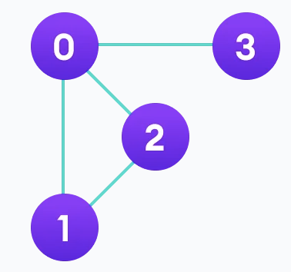

We can represent this graph in the form of a linked list on a computer as shown below.

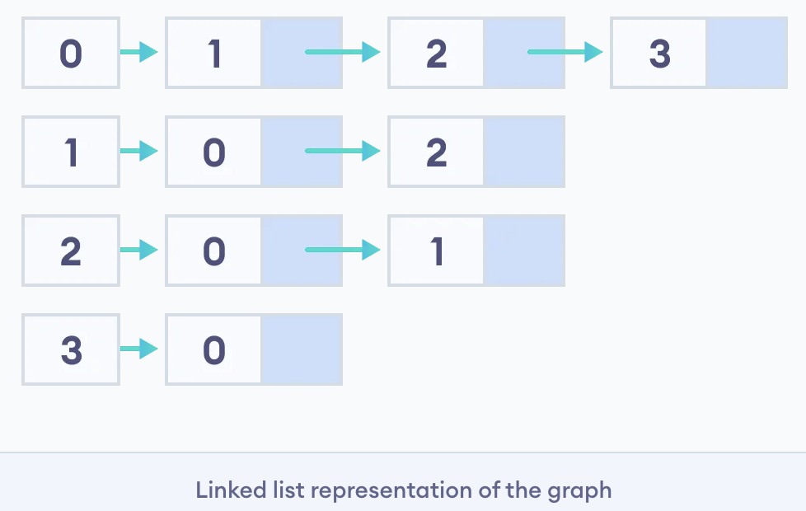

Here, 0, 1, 2, 3 are the vertices and each of them forms a linked list with all of its adjacent vertices. For instance, vertex 1 has two adjacent vertices 0 and 2. Therefore, 1 is linked with 0 and 2 in the figure above.

**Pros of Adjacency List**

* An adjacency list is efficient in terms of storage because we only need to store the values for the edges. For a sparse graph with millions of vertices and edges, this can mean a lot of saved space.
* It also helps to find all the vertices adjacent to a vertex easily.

**Cons of Adjacency List**

* Finding the adjacent list is not quicker than the adjacency matrix because all the connected nodes must be first explored to find them.

**Depth First Search (DFS)**

Depth first Search or Depth first traversal is a **recursive algorithm for searching all the vertices of a graph or tree data structure**. Traversal means visiting all the nodes of a graph.

**Depth First Search Algorithm**

A standard DFS implementation puts each vertex of the graph into one of two categories:

1. Visited
2. Not Visited

The purpose of the algorithm is to mark each vertex as visited while avoiding cycles.

The DFS algorithm works as follows:

1. Start by putting any one of the graph's vertices on top of a stack.
2. Take the top item of the stack and add it to the visited list.
3. Create a list of that vertex's adjacent nodes. Add the ones which aren't in the visited list to the top of the stack.
4. Keep repeating steps 2 and 3 until the stack is empty.

**Depth First Search Example**

Let's see how the Depth First Search algorithm works with an example. We use an undirected graph with 5 vertices.

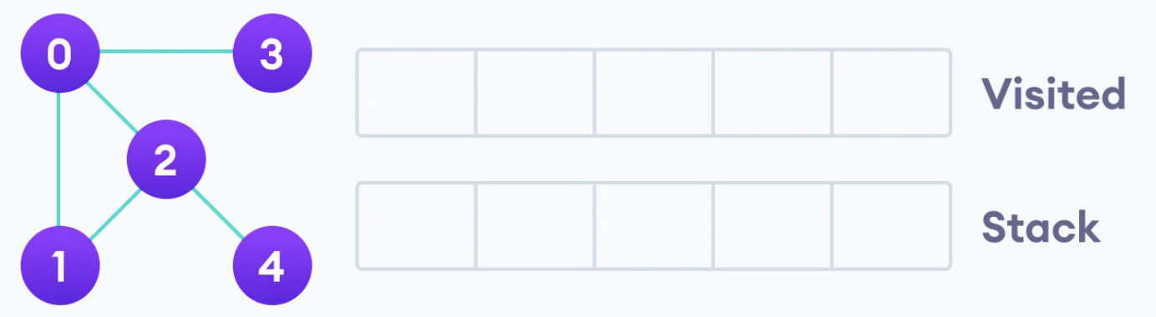

We start from vertex 0, the DFS algorithm starts by putting it in the Visited list and putting all its adjacent vertices in the stack.

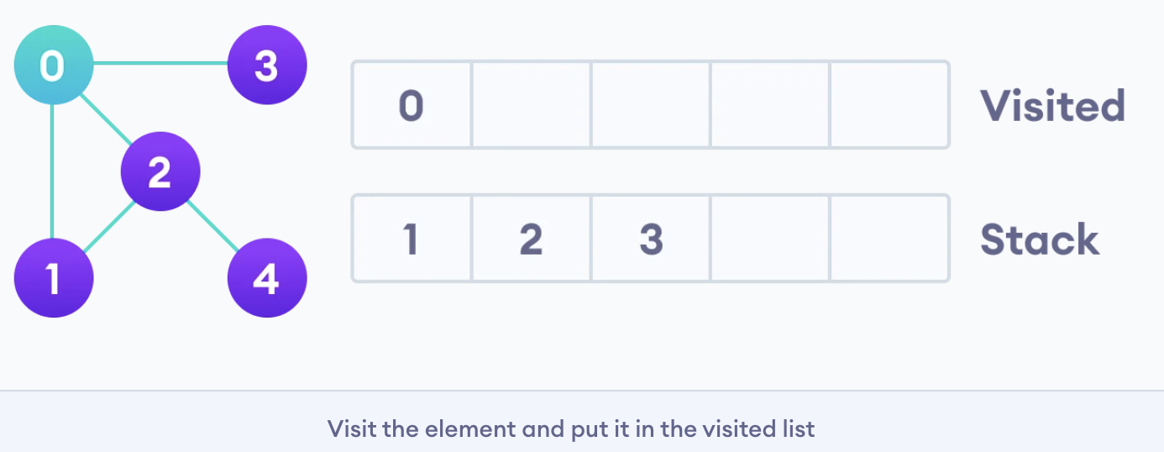

Next, we visit the element at the top of stack i.e. 1 and go to its adjacent nodes. Since 0 has already been visited, we visit 2 instead.

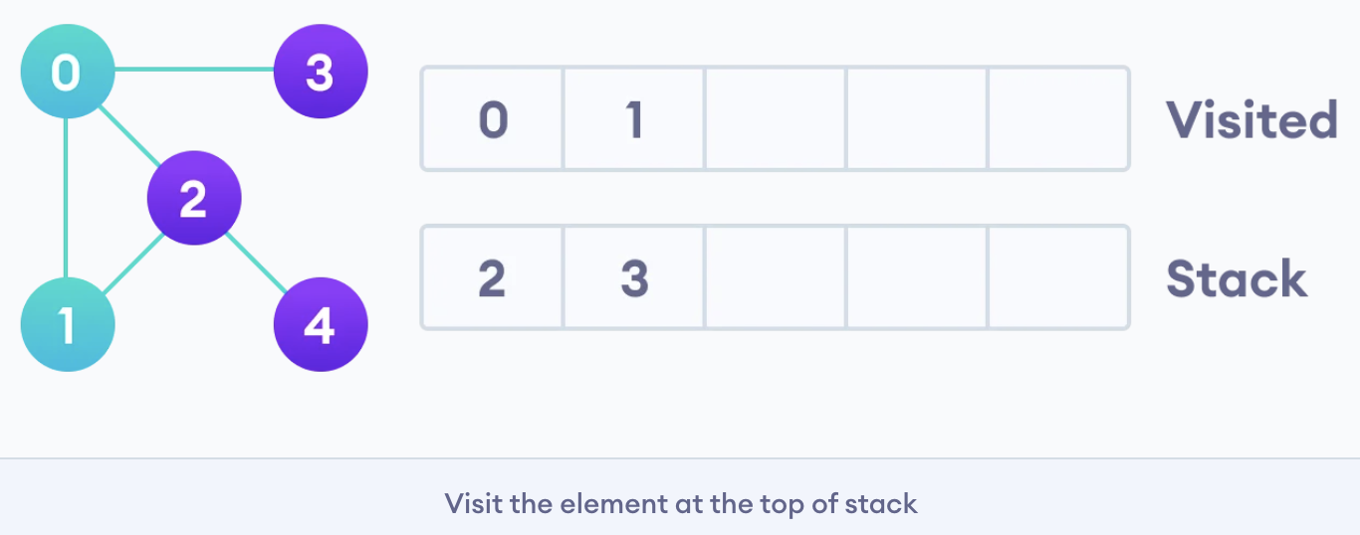

Vertex 2 has an unvisited adjacent vertex in 4, so we add that to the top of the stack and visit it.

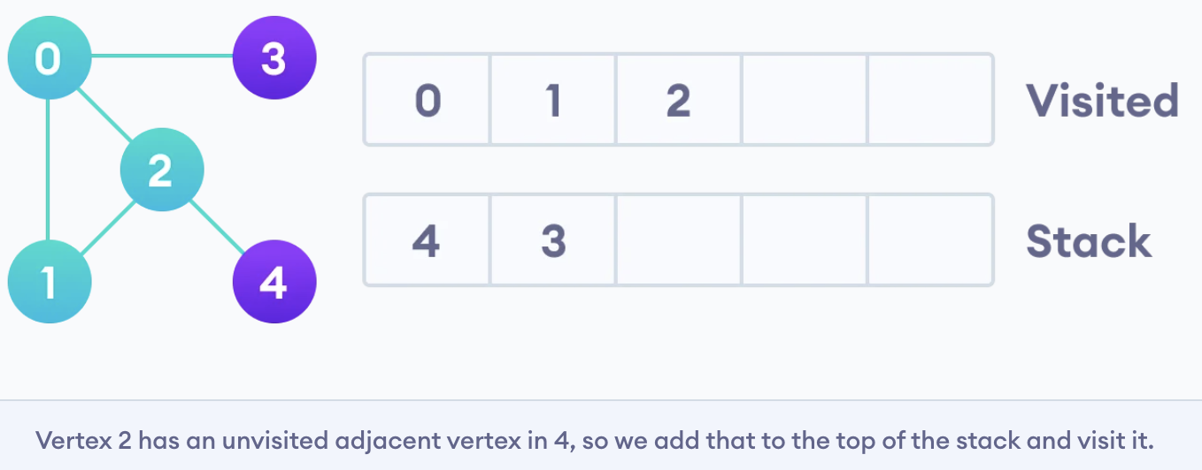

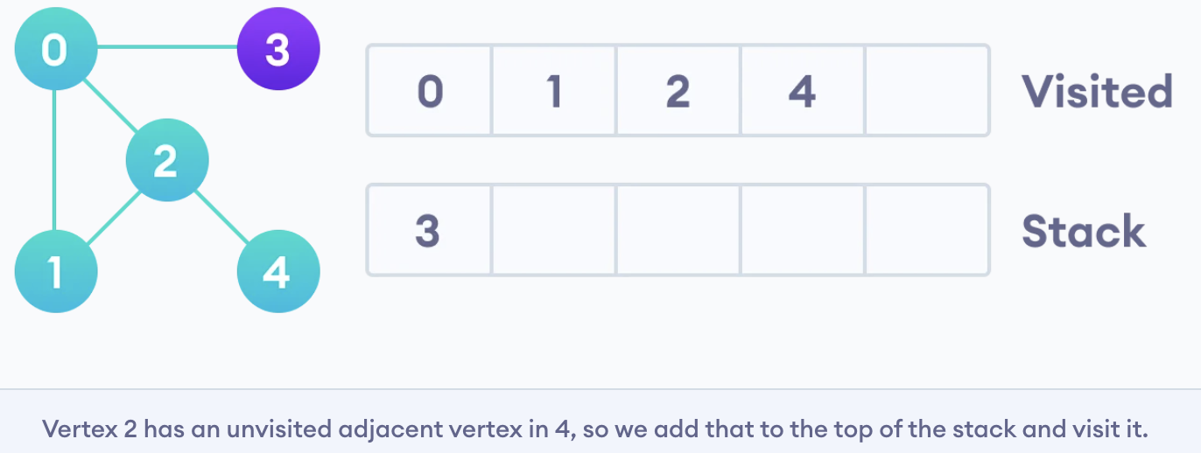

After we visit the last element 3, it doesn't have any unvisited adjacent nodes, so we have completed the Depth First Traversal of the graph.

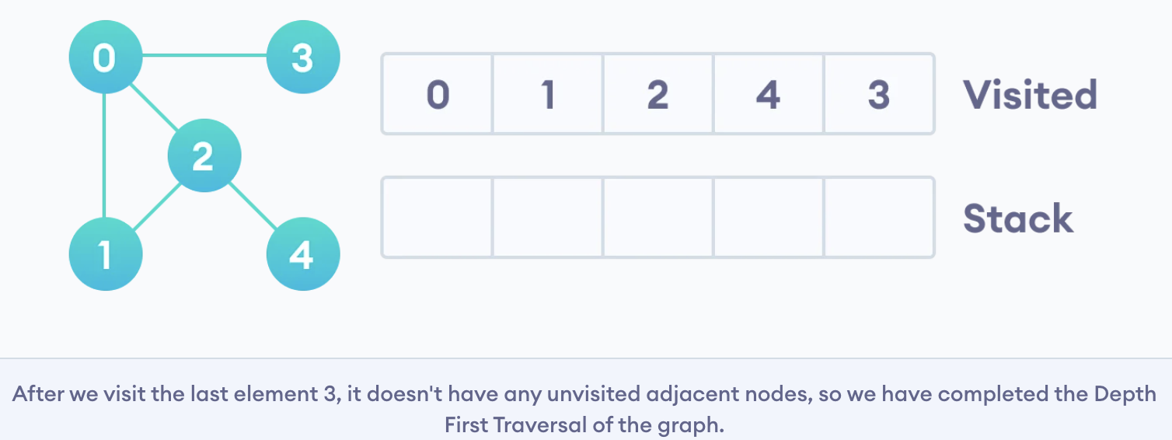

**Depth First Search Time Complexity**

The time complexity of the DFS algorithm is represented in the form of **O(V + E)**, where **V is the number of nodes and E is the number of edges**.

**space complexity**

The space complexity of the algorithm is **O(V)**.

**Breadth first search**

**Traversal means visiting all the nodes of a graph**. Breadth First Traversal or Breadth First Search is a **recursive algorithm for searching all the vertices of a graph or tree data structure**.

**BFS algorithm**

A standard BFS implementation puts each vertex of the graph into one of two categories:

1. Visited
2. Not Visited

The purpose of the algorithm is to mark each vertex as visited while avoiding cycles.

The algorithm works as follows:

1. Start by putting any one of the graph's vertices at the back of a queue.
2. Take the front item of the queue and add it to the visited list.
3. Create a list of that vertex's adjacent nodes. Add the ones which aren't in the visited list to the back of the queue.
4. Keep repeating steps 2 and 3 until the queue is empty.

The graph might have two different disconnected parts so to make sure that we cover every vertex, we can also run the BFS algorithm on every node

**BFS example**

Let's see how the Breadth First Search algorithm works with an example. We use an undirected graph with 5 vertices.

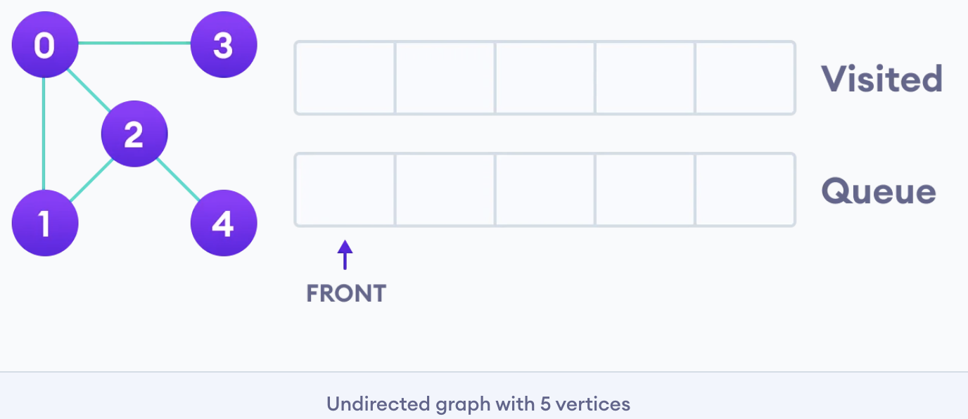

We start from vertex 0, the BFS algorithm starts by putting it in the Visited list and putting all its adjacent vertices in the stack.

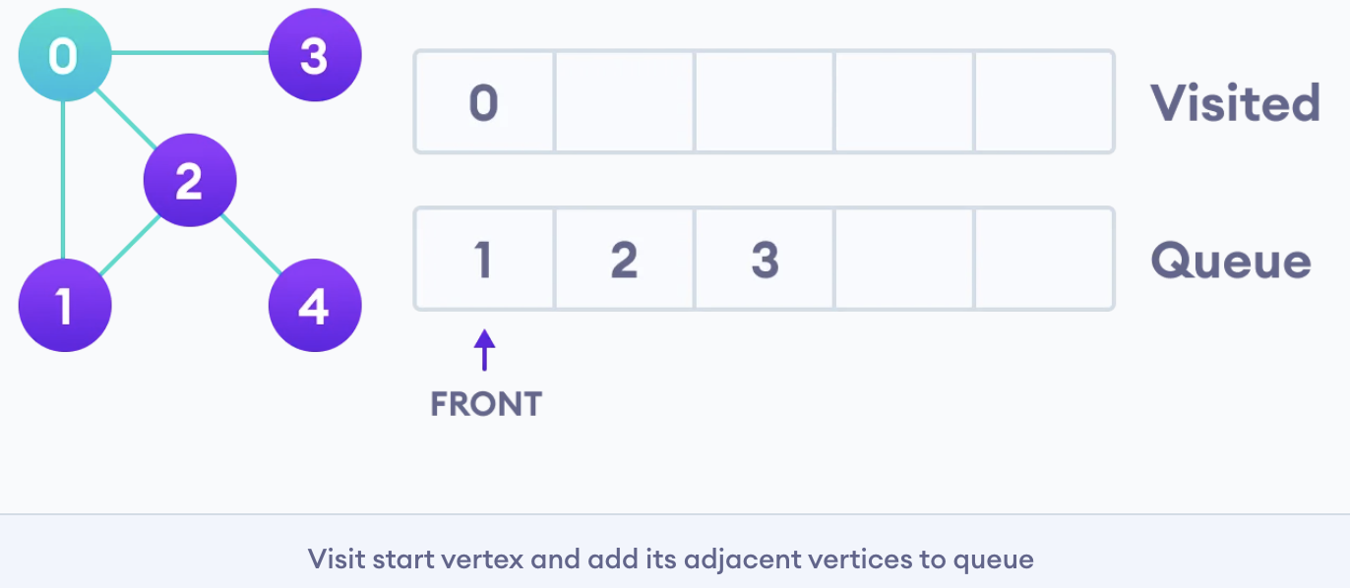

Next, we visit the element at the front of queue i.e. 1 and go to its adjacent nodes. Since 0 has already been visited, we visit 2 instead.

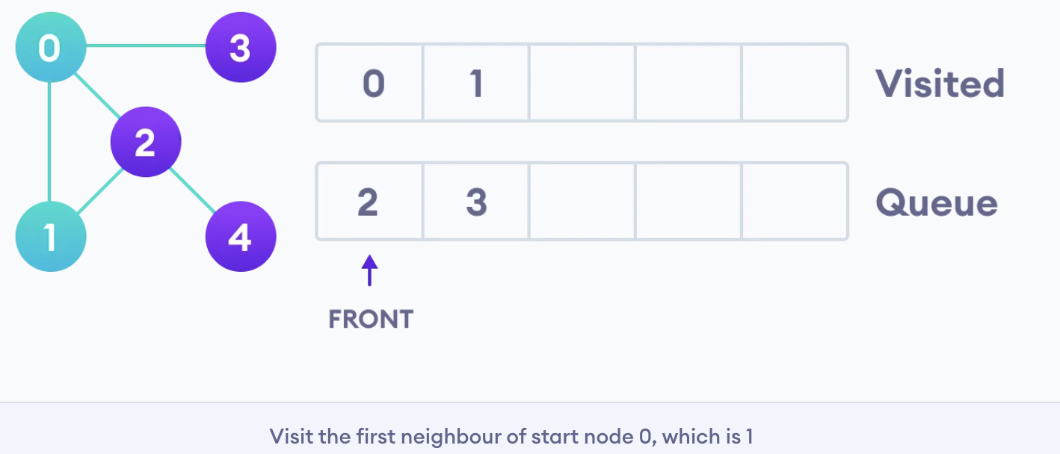

Vertex 2 has an unvisited adjacent vertex in 4, so we add that to the back of the queue and visit 3, which is at the front of the queue.

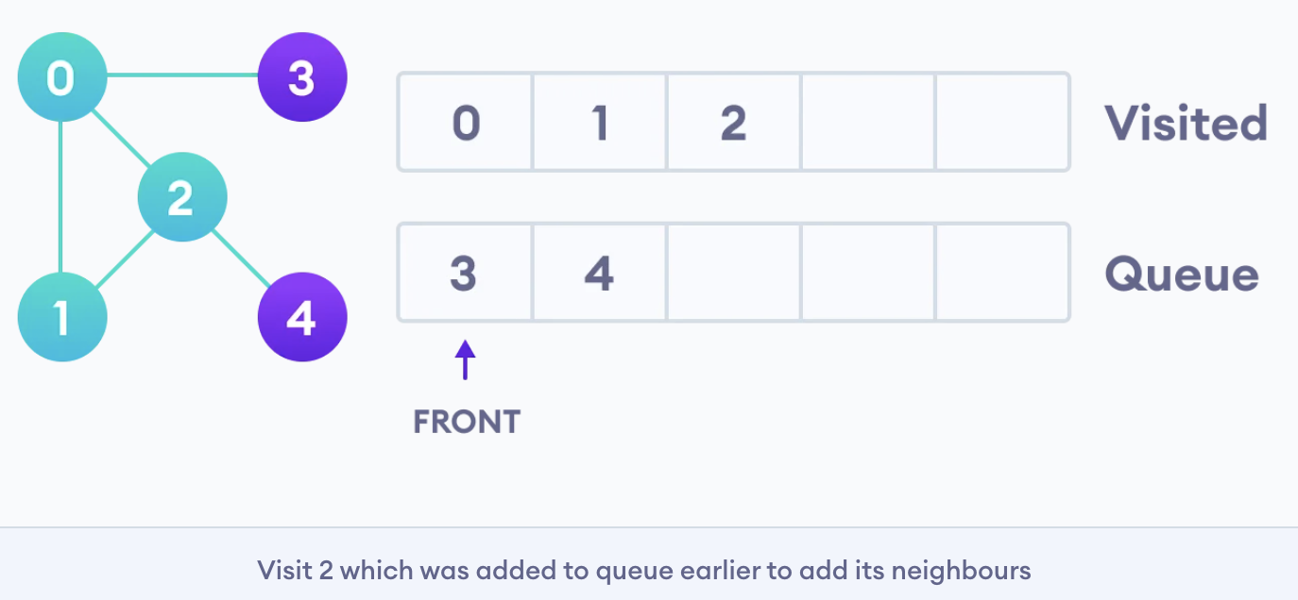

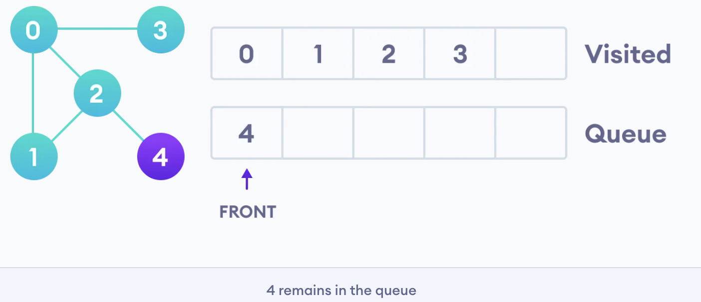

Only 4 remains in the queue since the only adjacent node of 3 i.e. 0 is already visited. We visit it.

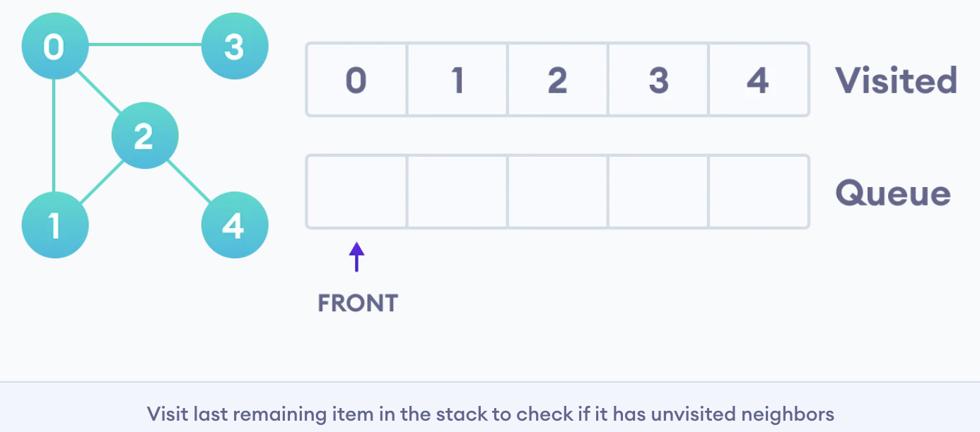

Since the queue is empty, we have completed the Breadth First Traversal of the graph.

**BFS Algorithm Time Complexity**

The time complexity of the BFS algorithm is represented in the form of **O(V + E)**, where **V is the number of nodes and E is the number of edges**.

**Space Complexity**

The space complexity of the algorithm is **O(V)**.

**Bellman Ford's Algorithm**

<https://www.programiz.com/dsa/bellman-ford-algorithm>

**---------------------------------------------- GCD or HCF ---------------------------------------------------**

**Calculate GCD (Greatest Common Divisor) or HCF(Highest Common Factor):**

int getGCD(int a, int b) {

if (b == 0)

return a;

else

return getGCD(b, a%b);

}

ex: getGCD(3, 12) -->. GCD = 3

**-------------------------------- Sorting and Searching Algorithms -------------------------------------**

**Sorting Algorithm**

**Bubble Sort**

**Bubble sort** is a sorting algorithm that **compares two adjacent elements and swaps them** if they are not in the intended order.

**Time Complexity:** O(n*n) or O(n^2)

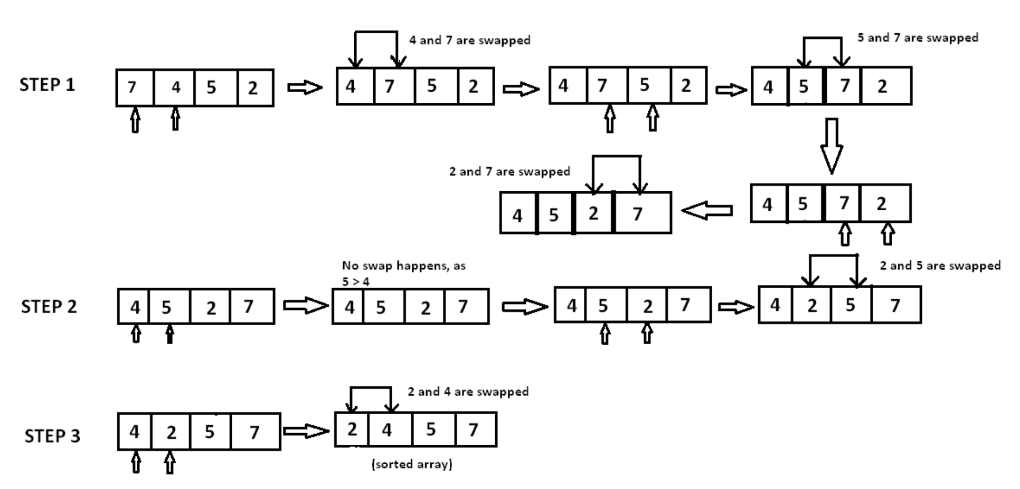

void bubble_sort( int A[ ], int n ) {

int temp;

for(int k = 0; k< n-1; k++) {

// (n-k-1) is for ignoring comparisons of elements which have already been compared in earlier iterations

for(int i = 0; i < n-k-1; i++) {

if(A[ i ] > A[ i+1] ) {

// here swapping of positions is being done.

temp = A[ i ];

A[ i ] = A[ i+1 ];

A[ i + 1] = temp;

}

}

}

}

**Selection sort:**

The Selection sort algorithm is based on the idea of finding the minimum or maximum element in an unsorted array and then putting it in its correct position in a sorted array.

**Time Complexity:** O(n*n) or O(n^2)

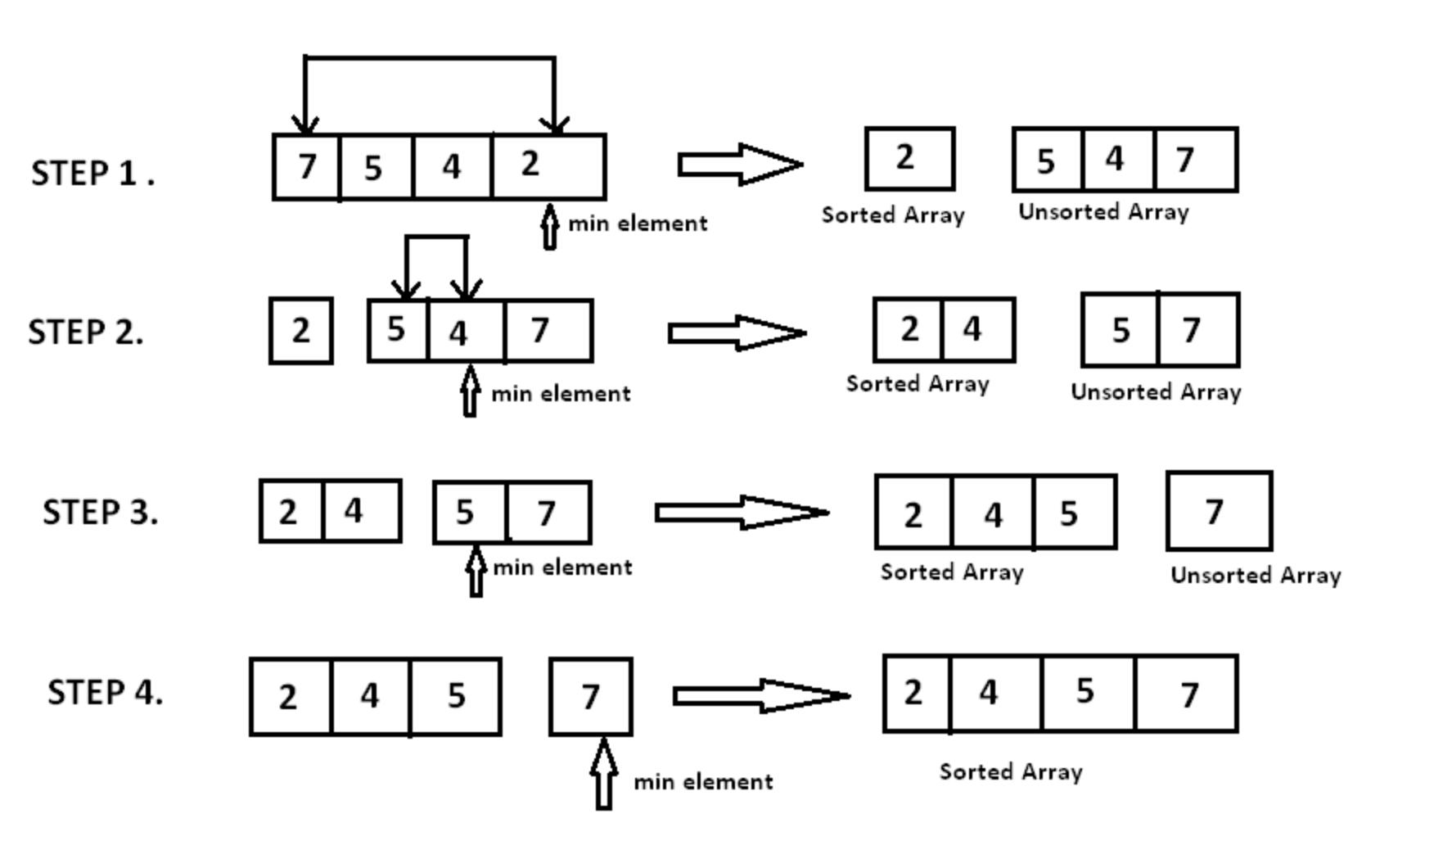

void selection_sort (int A[ ], int n) {

// temporary variable to store the position of minimum element

int minimum;

// reduces the effective size of the array by one in each iteration.

for(int i = 0; i < n-1 ; i++) {

// assuming the first element to be the minimum of the unsorted array .

minimum = i ;

// gives the effective size of the unsorted array .

for(int j = i+1; j < n ; j++ ) {

if(A[ j ] < A[ minimum ]) { //finds the minimum element

minimum = j ;

}

}

// putting minimum element on its proper position.

swap ( A[ minimum ], A[ i ]) ;

}

}

**Insertion Sort**

Insertion sort is based on the idea that one element from the input elements is consumed in each iteration to find its correct position i.e., the position to which it belongs in a sorted array.

It iterates the input elements by growing the sorted array at each iteration. It compares the current element with the largest value in the sorted array. If the current element is greater, then it leaves the element in its place and moves on to the next element else it finds its correct position in the sorted array and moves it to that position. This is done by shifting all the elements, which are larger than the current element, in the sorted array to one position ahead

**Time Complexity:** O(n*n) or O(n^2)

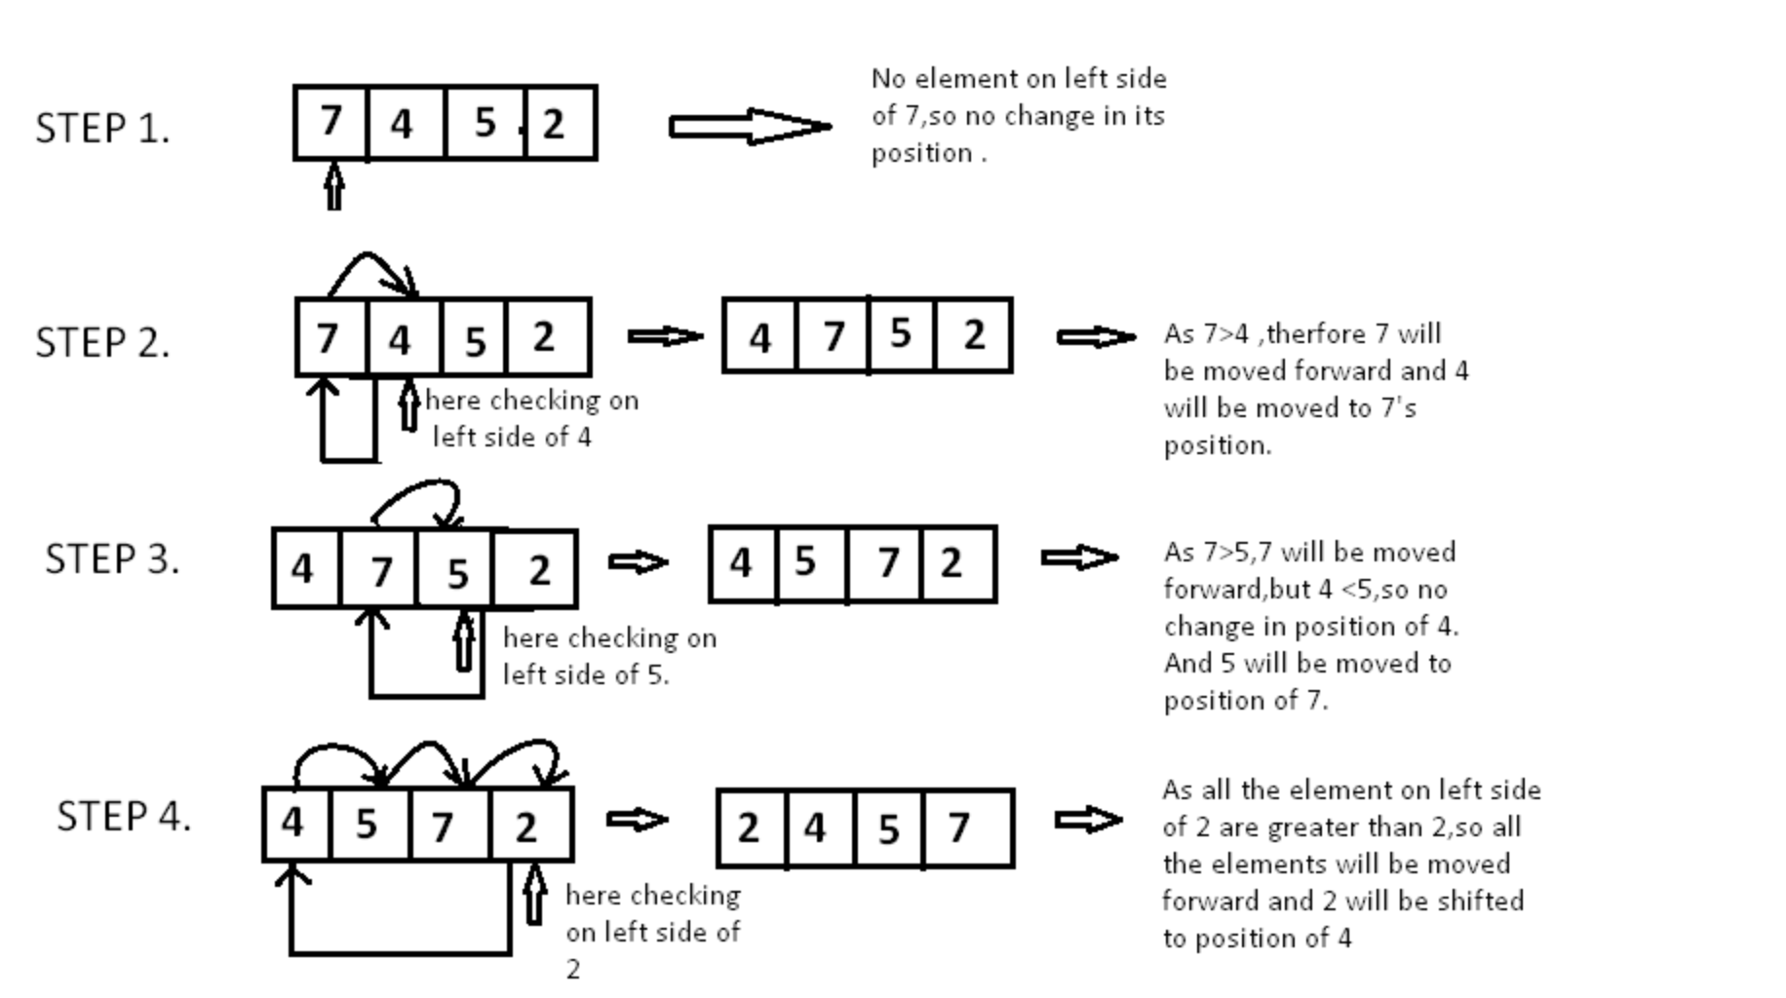

void insertion_sort ( int A[ ] , int n)

{

for( int i = 0 ;i < n ; i++ ) {

/*storing current element whose left side is checked for its correct position .*/

int temp = A[ i ];

int j = i;

/* check whether the adjacent element in left side is greater or less than the current element. */

while( j > 0 && temp < A[ j -1]) {

// moving the left side element to one position forward.

A[ j ] = A[ j-1];

j= j - 1;

}

// moving current element to its correct position.

A[ j ] = temp;

}

}

**Merge Sort**

Merge sort is a divide-and-conquer algorithm based on the idea of breaking down a list into several sub-lists until each sublist consists of a single element and merging those sublists in a manner that results into a sorted list.

**Time Complexity:** Log N

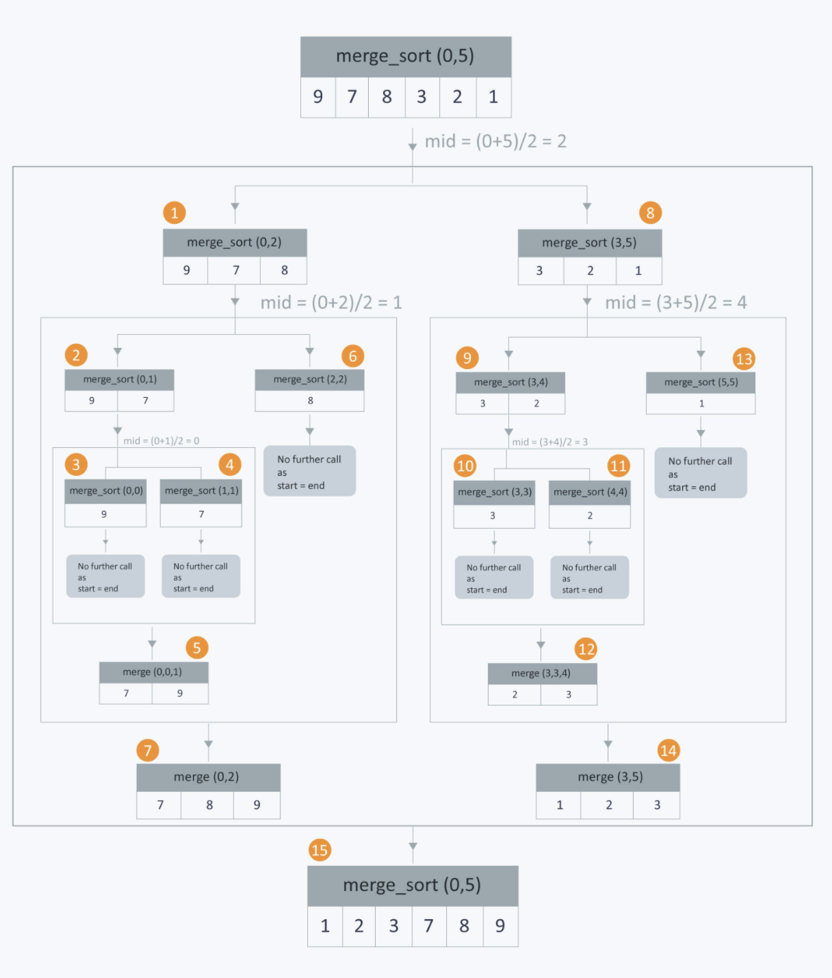

**Quick sort:**

Quick sort is based on the **divide-and-conquer approach** based on the idea of **choosing one element as a pivot** element and partitioning the array around it such that: **Left side of pivot contains all the elements that are less than the pivot element,** **Right side contains all elements greater than the pivot**

It reduces the space complexity and removes the use of the auxiliary array that is used in merge sort. Selecting a random pivot in an array results in an improved time complexity in most of the cases.

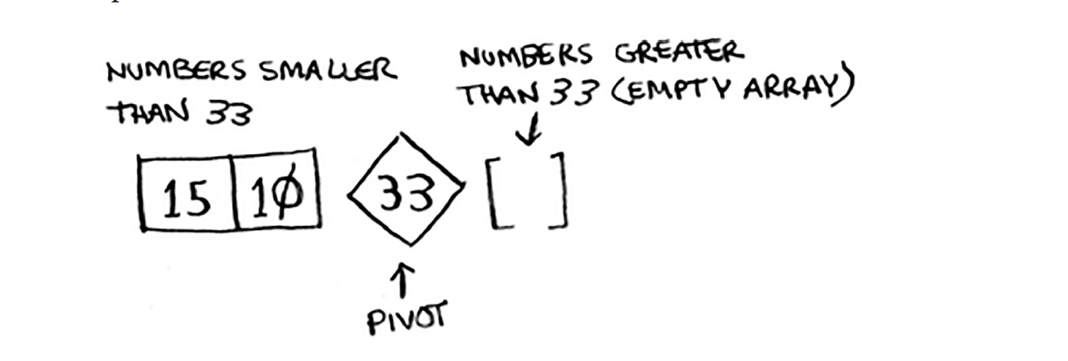

**Counting Sort**

Counting sort is a sorting algorithm that sorts the elements of an array by counting the number of occurrences of each unique element in the array. The count is stored in an auxiliary array and the sorting is done by mapping the count as an index of the auxiliary array.

**Working of Counting Sort**

1. Find out the maximum element (let it be max) from the given array.

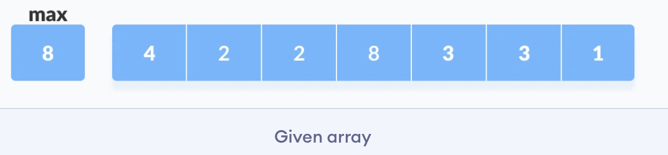

1. Initialize an array of length max+1 with all elements 0. This array is used for storing the count of the elements in the array.

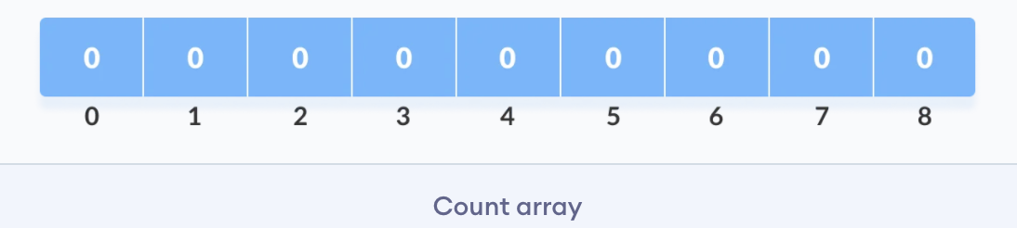

1. Store the count of each element at their respective index in count array

For example: if the count of element 3 is 2 then, 2 is stored in the 3rd position of count array. If element "5" is not present in the array, then 0 is stored in 5th position.

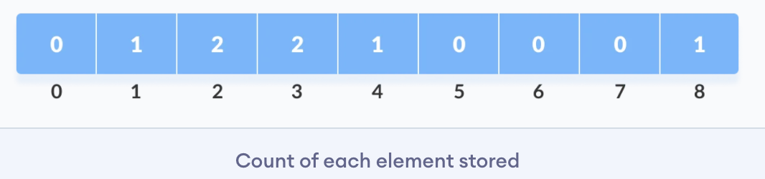

1. Store cumulative sum of the elements of the count array. It helps in placing the elements into the correct index of the sorted array.

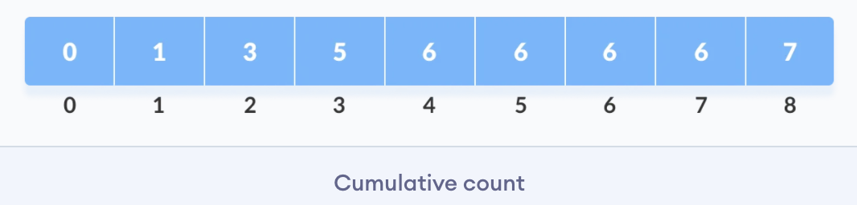

1. Find the index of each element of the original array in the count array. This gives the cumulative count. Place the element at the index calculated as shown in figure below.

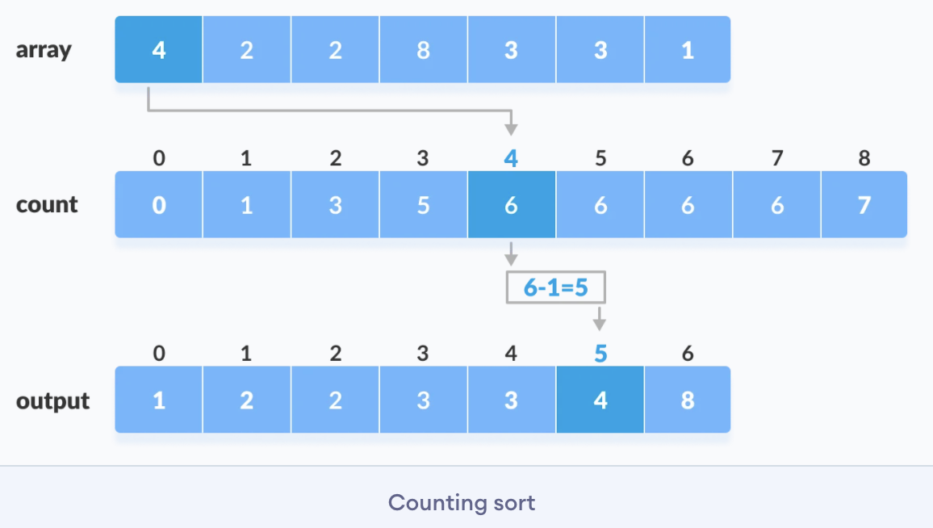

1. After placing each element at its correct position, decrease its count by one.

**Time Complexity: O(n+k)**

**Radix Sort**

<https://www.programiz.com/dsa/radix-sort>

**Bucket Sort**

<https://www.programiz.com/dsa/bucket-sort>

**Searching Algorithm**

**Linear Search**

Linear search is used on a collections of items. It relies on the technique of traversing a list from start to end by exploring properties of all the elements that are found on the way.

**Time Complexity:** O(n)

**Binary Search:**

Search a sorted array by repeatedly dividing the search interval in half. Begin with an interval covering the whole array. If the value of the search key is less than the item in the middle of the interval, narrow the interval to the lower half. Otherwise, narrow it to the upper half. Repeatedly check until the value is found or the interval is empty.

**Time Complexity:** O(log n)

**Ternary Search:**

.............................................https://www.hackerearth.com/practice/algorithms/searching/ternary-search/tutorial/

**Time Complexity:** .......

**-------------------------------------------- Greedy Algorithms --------------------------------------------**

**Greedy Algorithm**

A greedy algorithm is an approach for solving a problem by selecting the best option available at the moment. It doesn't worry whether the current best result will bring the overall optimal result.

The algorithm never reverses the earlier decision even if the choice is wrong. It works in a top-down approach.

This algorithm may not produce the best result for all the problems. It's because it always goes for the local best choice to produce the global best result.

However, we can determine if the algorithm can be used with any problem if the problem has the following properties:

**1. Greedy Choice Property**

If an optimal solution to the problem can be found by choosing the best choice at each step without reconsidering the previous steps once chosen, the problem can be solved using a greedy approach. This property is called greedy choice property.

**2. Optimal Substructure**

If the optimal overall solution to the problem corresponds to the optimal solution to its subproblems, then the problem can be solved using a greedy approach. This property is called optimal substructure.

**Advantages of Greedy Approach**

* The algorithm is **easier to describe.**
* This algorithm can **perform better** than other algorithms (but, not in all cases).

**Drawback of Greedy Approach**

As mentioned earlier, the greedy algorithm doesn't always produce the optimal solution. This is the major disadvantage of the algorithm

For example, suppose we want to find the longest path in the graph below from root to leaf. Let's use the greedy algorithm here.

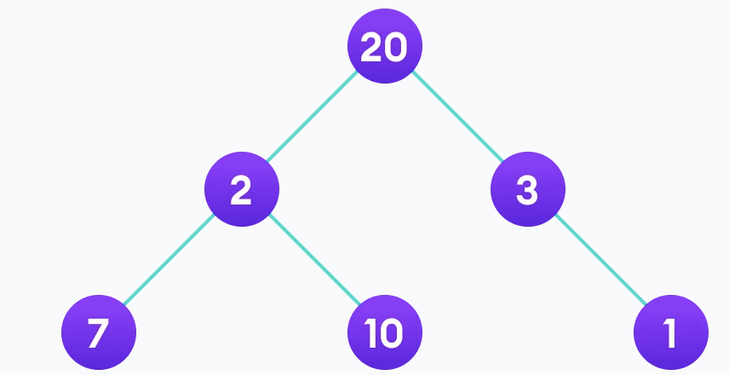

Greedy Approach

1. Let's start with the root node **20**. The weight of the right child is **3** and the weight of the left child is **2**.

2. Our problem is to find the largest path. And, the optimal solution at the moment is **3.** So, the greedy algorithm will choose **3**.

3. Finally the weight of an only child of **3** is **1**. This gives us our final **result 20 + 3 + 1 = 24.**

However, it is not the optimal solution. There is another path that carries more weight **(20 + 2 + 10 = 32)** as shown in the image below.

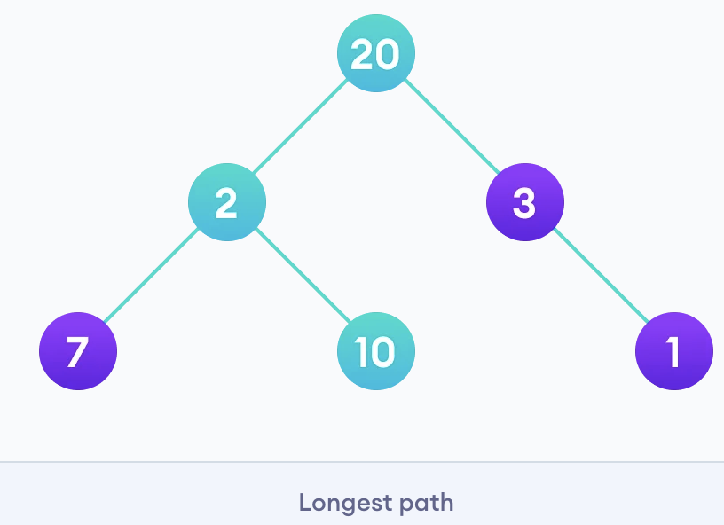

Therefore, greedy algorithms do not always give an optimal/feasible solution.

**Greedy Algorithm**

1. To begin with, the solution set (containing answers) is empty.
2. At each step, an item is added to the solution set until a solution is reached.
3. If the solution set is feasible, the current item is kept.
4. Else, the item is rejected and never considered again.

**Different Types of Greedy Algorithm**

* Selection Sort
* Knapsack Problem
* Minimum Spanning Tree
* Single-Source Shortest Path Problem
* Job Scheduling Problem
* Prim's Minimal Spanning Tree Algorithm
* Kruskal's Minimal Spanning Tree Algorithm
* Dijkstra's Minimal Spanning Tree Algorithm
* Huffman Coding
* Ford-Fulkerson Algorithm

**Ford-Fulkerson Algorithm**

Ford-Fulkerson algorithm is a greedy approach for **calculating the maximum possible flow in a network or a graph**.

A term**, flow network**, is used to describe a network of vertices and edges with a source (S) and a sink (T). Each vertex, except **S** and **T**, can receive and send an equal amount of stuff through it. **S** can only send and **T** can only receive stuff.

We can visualize the understanding of the algorithm using a flow of liquid inside a network of pipes of different capacities. Each pipe has a certain capacity of liquid it can transfer at an instance. For this algorithm, we are going to find how much liquid can be flowed from the source to the sink at an instance using the network.

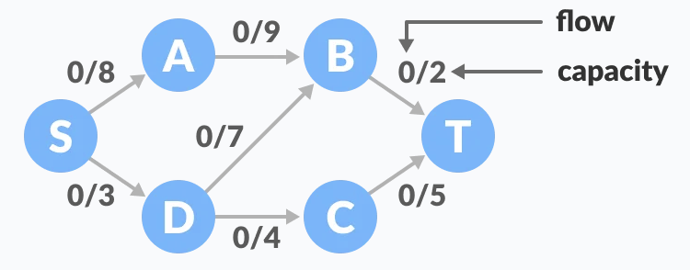

**Terminologies Used:**

* **Augmenting Path:** It is the path available in a flow network.
* **Residual Graph:** It represents the flow network that has additional possible flow.
* **Residual Capacity:** It is the capacity of the edge after subtracting the flow from the maximum capacity.

**How Ford-Fulkerson Algorithm works?**

The algorithm follows:

1. Initialize the flow in all the edges to 0.
2. While there is an augmenting path between the source and the sink, add this path to the flow.
3. Update the residual graph.

We can also consider reverse-path if required because if we do not consider them, we may never find a maximum flow.

**Ford-Fulkerson Example**

The flow of all the edges is 0 at the beginning.

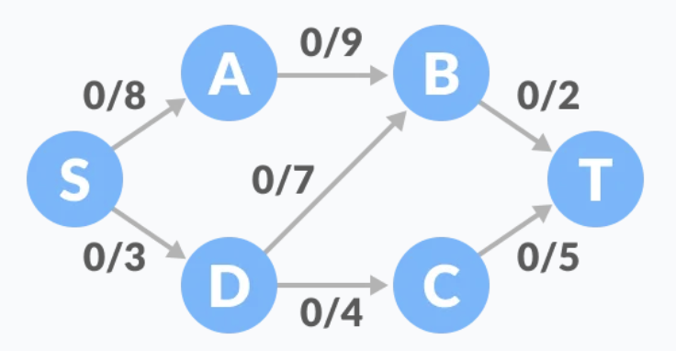

1. Select any arbitrary path from S to T. In this step, we have selected path **S-A-B-T.**

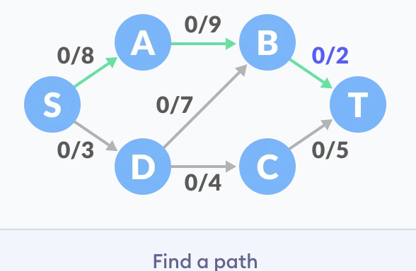

The minimum capacity among the three edges is 2 (B-T). Based on this, update the flow/capacity for each path.

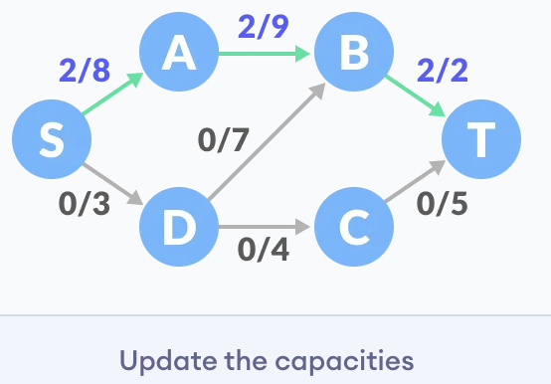

2. Select another path **S-D-C-T.** The minimum capacity among these edges is **3 (S-D).**

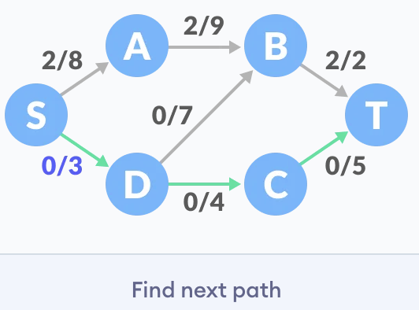

Update the capacities according to this.

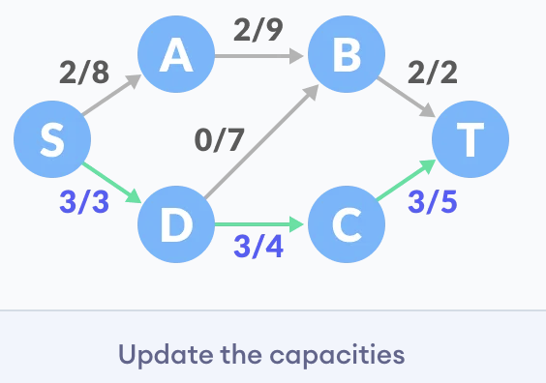

3. Now, let us consider the **reverse-path B-D** as well. Selecting path **S-A-B-D-C-T.** The minimum residual capacity among the edges is **1 (D-C).**

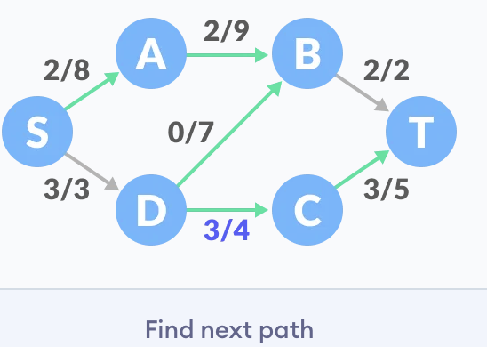

Updating the capacities.

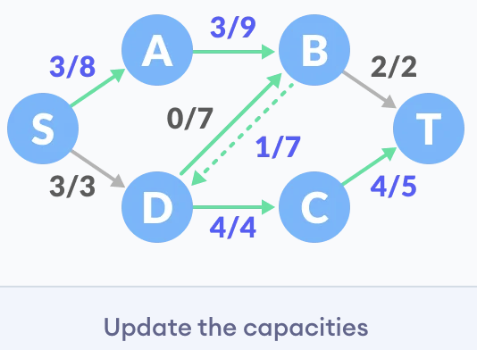

The capacity for forward and reverse paths are considered separately.

4. Adding **all the flows = 2 + 3 + 1 = 6**, which is the maximum possible flow on the flow network.

**Note:** that if the capacity for any edge is full, then that path cannot be used.

**Dijkstra's Algorithm**

Dijkstra's algorithm allows us to find the shortest path between any two vertices of a graph.

It differs from the minimum spanning tree because the shortest distance between two vertices might not include all the vertices of the graph.

**How Dijkstra's Algorithm works**

Dijkstra's Algorithm works on the basis that any subpath **B -> D** of the shortest path **A -> D** between vertices A and D is also the shortest path between vertices B and D.

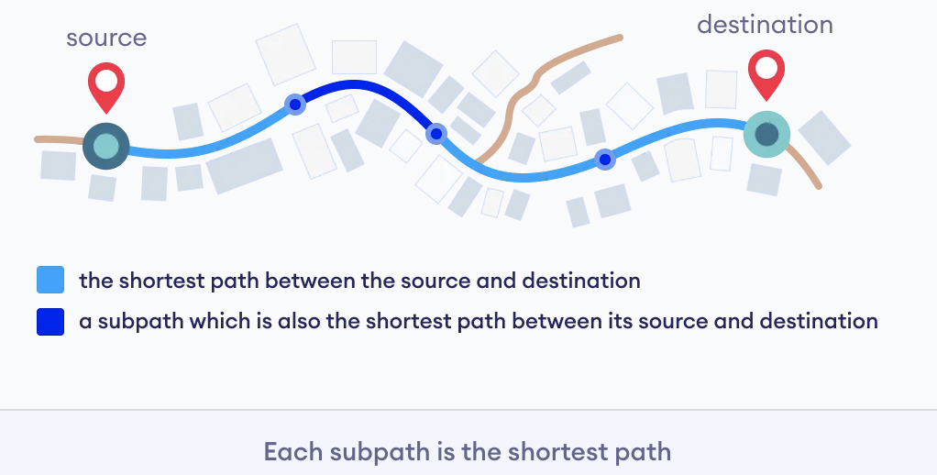

Djikstra used this property in the opposite direction i.e we overestimate the distance of each vertex from the starting vertex. Then we visit each node and its neighbors to find the shortest subpath to those neighbors.

The algorithm uses a greedy approach in the sense that we find the next best solution hoping that the end result is the best solution for the whole problem.

**Example of Dijkstra's algorithm**

It is easier to start with an example and then think about the algorithm.

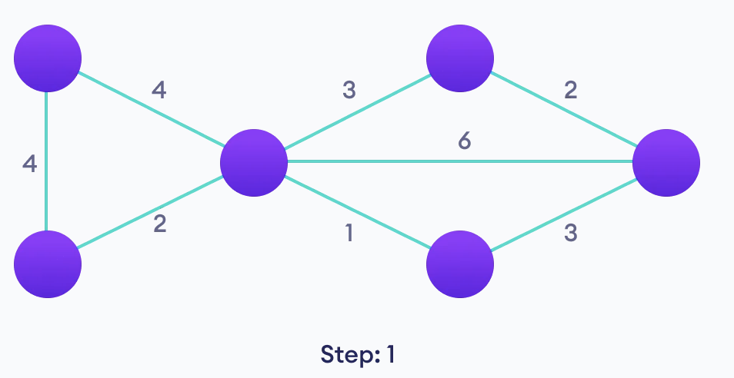

Start with a weighted graph

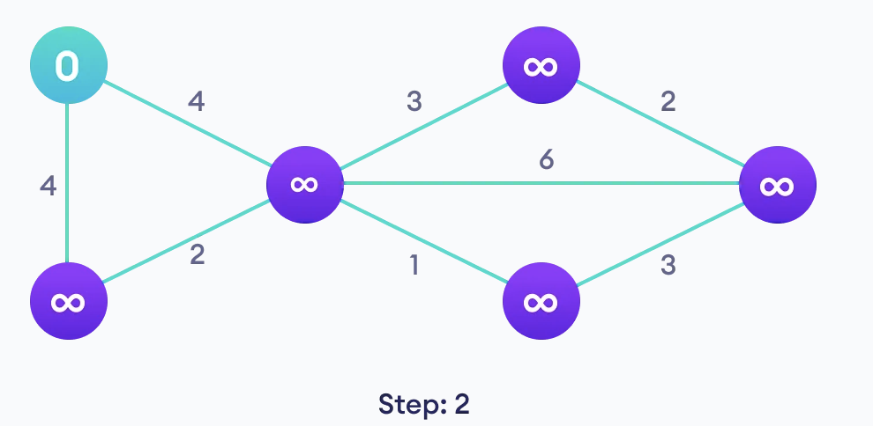

Choose a starting vertex and assign infinity path values to all other devices

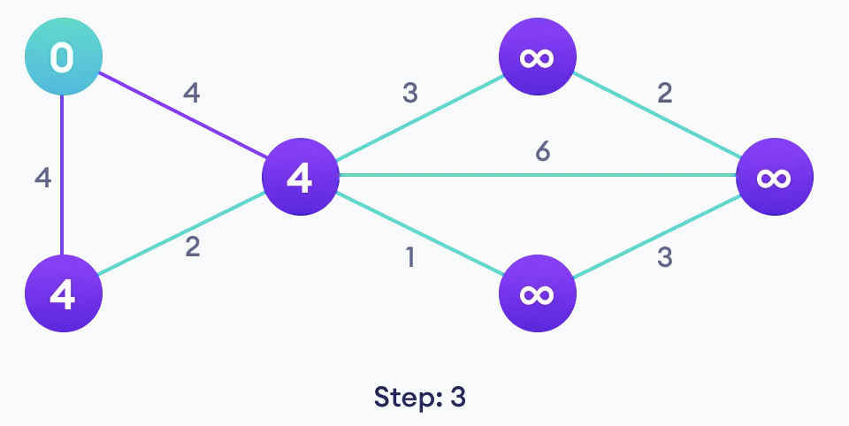

Go to each vertex and update its path length

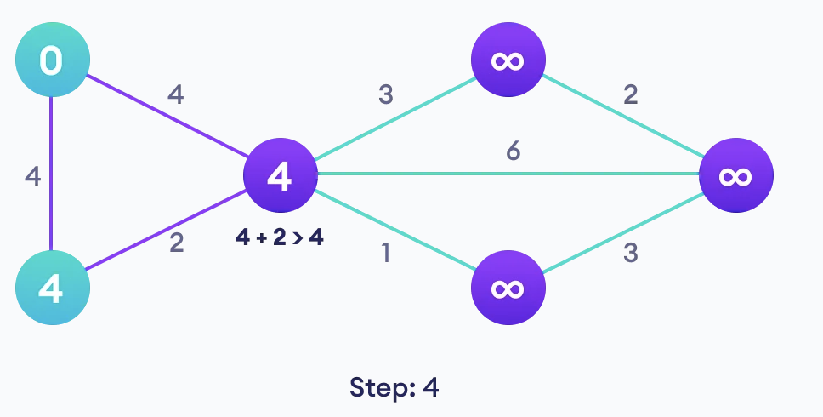

If the path length of the adjacent vertex is lesser than new path length, don't update it

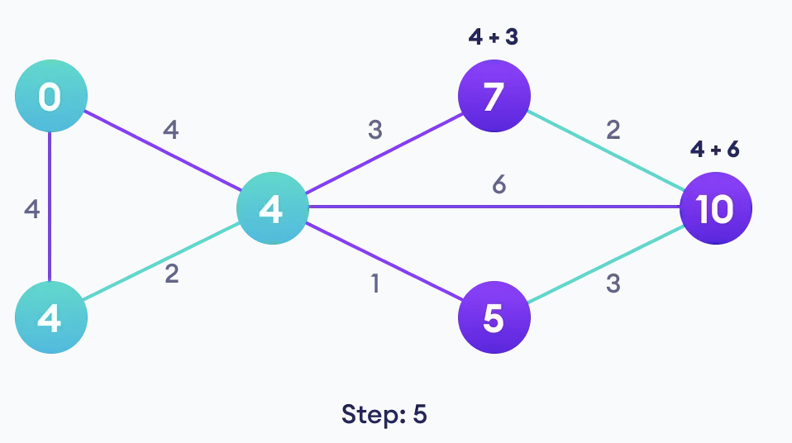

Avoid updating path lengths of already visited vertices

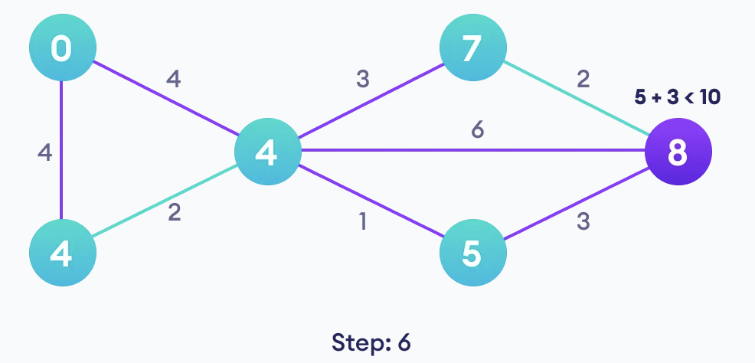

After each iteration, we pick the unvisited vertex with the least path length. So we choose 5 before 7

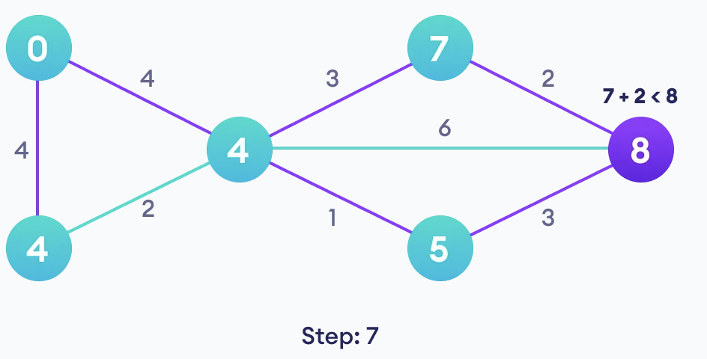

Notice how the rightmost vertex has its path length updated twice

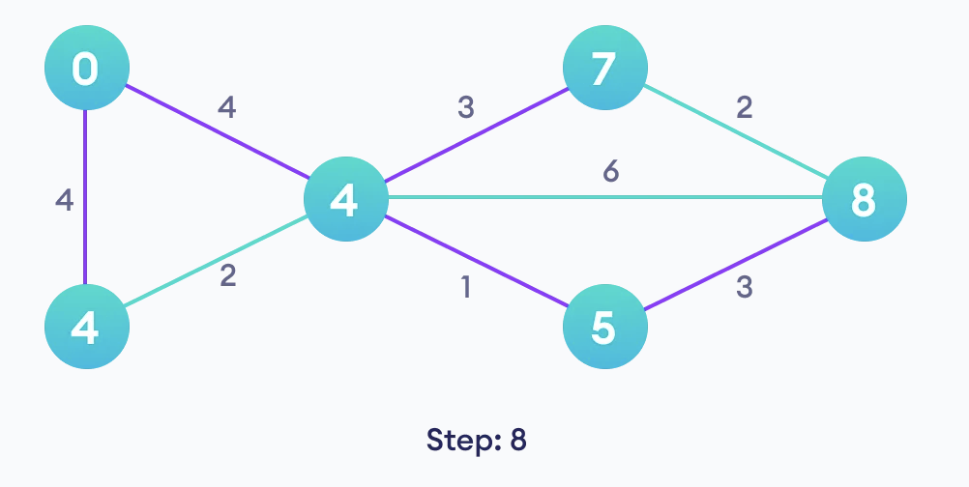

Repeat until all the vertices have been visited

**Dijkstra's Algorithm Time Complexity**

**O(E Log V)**,where, E is the number of edges and V is the number of vertices.

**Space Complexity: O(V)**

**Kruskal's Algorithm**

Kruskal's algorithm is a minimum spanning tree algorithm that takes a graph as input and finds the subset of the edges of that graph which

* form a tree that includes every vertex
* has the minimum sum of weights among all the trees that can be formed from the graph

**How Kruskal's algorithm works**

It falls under a class of algorithms called greedy algorithms that find the local optimum in the hopes of finding a global optimum.

We start from the edges with the lowest weight and keep adding edges until we reach our goal.

The steps for implementing Kruskal's algorithm are as follows:

1. Sort all the edges from low weight to high
2. Take the edge with the lowest weight and add it to the spanning tree. If adding the edge created a cycle, then reject this edge.
3. Keep adding edges until we reach all vertices.

**Example of Kruskal's algorithm**

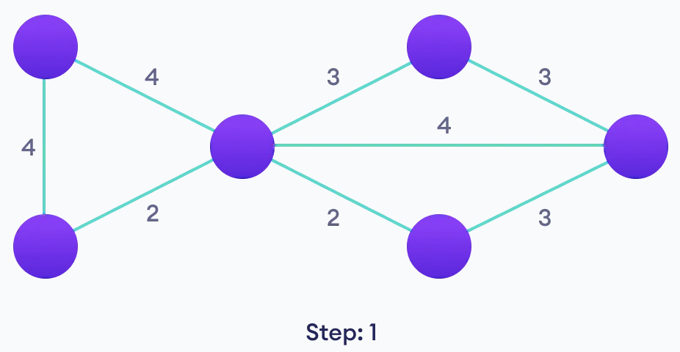

**Start with a weighted graph**

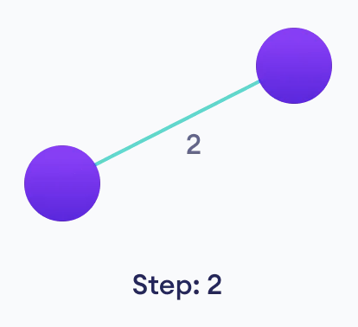

**Choose the edge with the least weight, if there are more than 1, choose anyone**

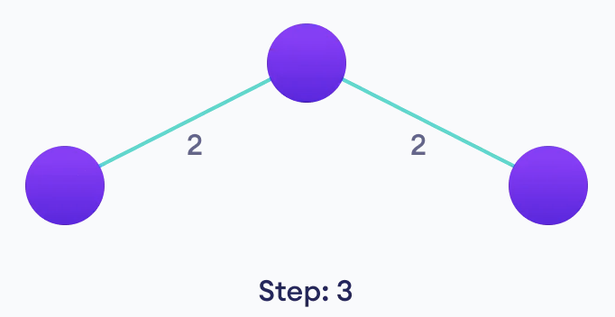

**Choose the next shortest edge and add it**

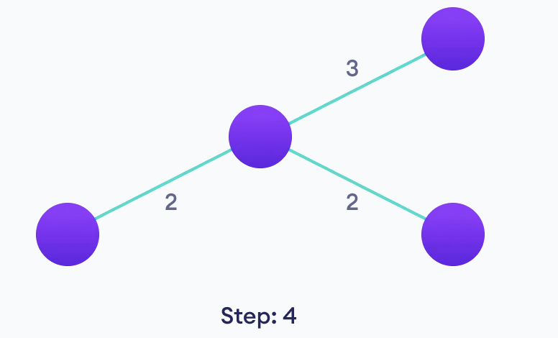

**Choose the next shortest edge that doesn't create a cycle and add it**

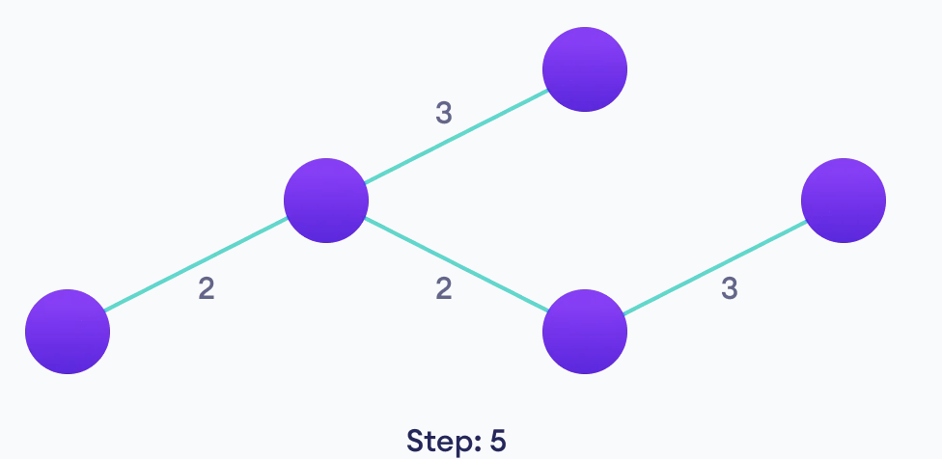

**Choose the next shortest edge that doesn't create a cycle and add it**

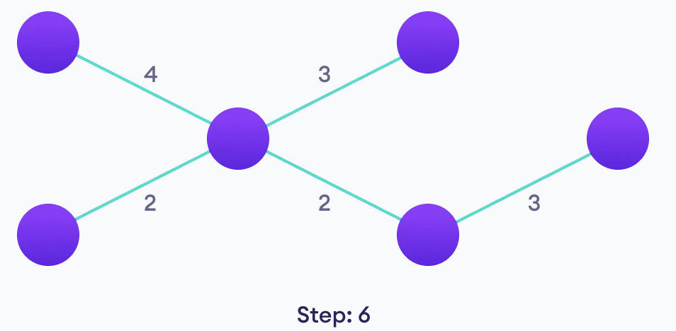

**Repeat until you have a spanning tree**

**Kruskal's vs Prim's Algorithm**

Prim's algorithm is another popular minimum spanning tree algorithm that uses a different logic to find the MST of a graph. Instead of starting from an edge, Prim's algorithm starts from a vertex and keeps adding lowest-weight edges which aren't in the tree, until all vertices have been covered.

**Kruskal's Algorithm Complexity**

The time complexity Of Kruskal's Algorithm is**: O(E log E)**

**Prim's Algorithm**

Prim's algorithm is a minimum spanning tree algorithm that takes a graph as input and finds the subset of the edges of that graph which

* form a tree that includes every vertex
* has the minimum sum of weights among all the trees that can be formed from the graph

**How Prim's algorithm works**

It falls under a class of algorithms called greedy algorithms that find the local optimum in the hopes of finding a global optimum.

We start from one vertex and keep adding edges with the lowest weight until we reach our goal.

**The steps for implementing Prim's algorithm are as follows:**

1. Initialize the minimum spanning tree with a vertex chosen at random.
2. Find all the edges that connect the tree to new vertices, find the minimum and add it to the tree
3. Keep repeating step 2 until we get a minimum spanning tree

**Example of Prim's algorithm**

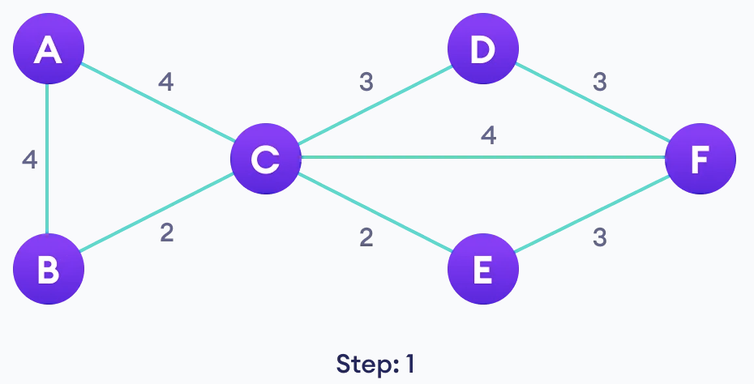

Start with a weighted graph



Choose a vertex

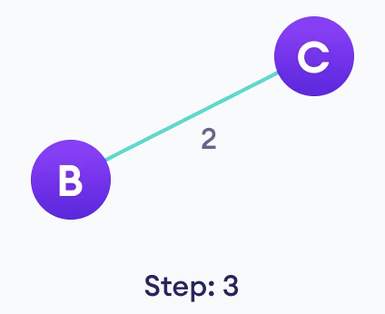

Choose the shortest edge from this vertex and add it

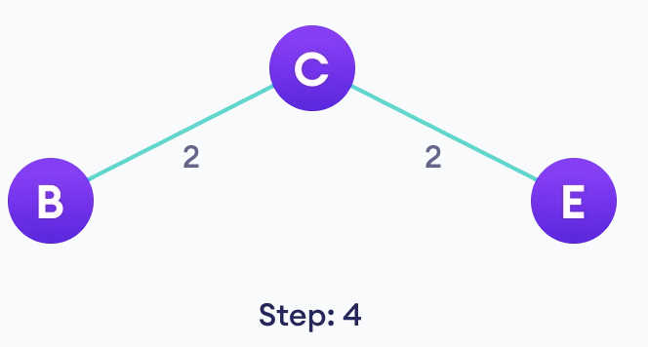

Choose the nearest vertex not yet in the solution

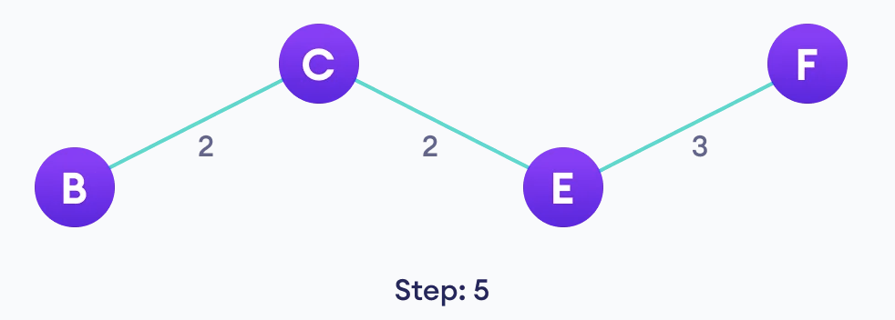

Choose the nearest edge not yet in the solution, if there are multiple choices, choose one at random

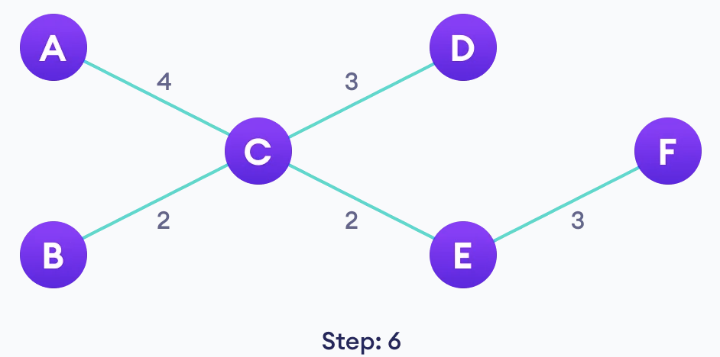

Repeat until you have a spanning tree

**Prim's vs Kruskal's Algorithm**

Kruskal's algorithm is another popular minimum spanning tree algorithm that uses a different logic to find the MST of a graph. Instead of starting from a vertex, Kruskal's algorithm sorts all the edges from low weight to high and keeps adding the lowest edges, ignoring those edges that create a cycle.

**Prim's Algorithm Complexity**

The time complexity of Prim's algorithm is **O(E log V).**

**Huffman Coding**

Huffman Coding is a technique of compressing data to reduce its size without losing any of the details. It was first developed by David Huffman.

Huffman Coding is generally useful to compress the data in which there are frequently occurring characters.

**How Huffman Coding works?**

Suppose the string below is to be sent over a network.

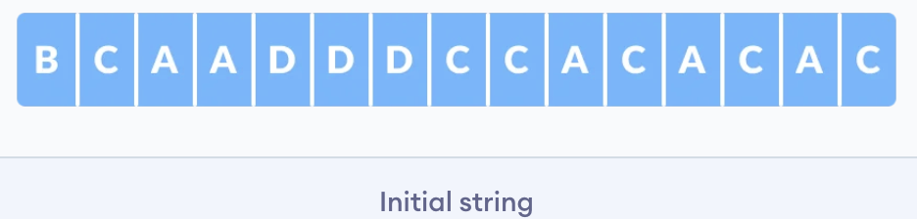

Each character occupies 8 bits. There are a total of 15 characters in the above string. Thus, a total of 8 * 15 = 120 bits are required to send this string.

Using the Huffman Coding technique, we can compress the string to a smaller size.

Huffman coding first creates a tree using the frequencies of the character and then generates code for each character.

Once the data is encoded, it has to be decoded. Decoding is done using the same tree.

Huffman Coding prevents any ambiguity in the decoding process using the concept of **prefix code** ie. a code associated with a character should not be present in the prefix of any other code. The tree created above helps in maintaining the property.

**Huffman coding is done with the help of the following steps.**

1. Calculate the frequency of each character in the string.

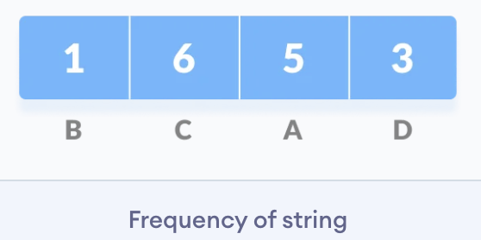

2. Sort the characters in increasing order of the frequency. These are stored in a priority queue Q.

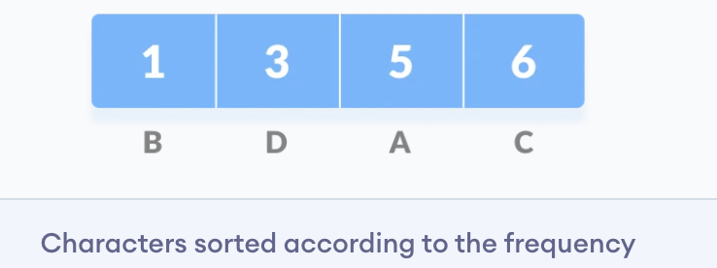

3. Make each unique character as a leaf node.

4. Create an empty node z. Assign the minimum frequency to the left child of z and assign the second minimum frequency to the right child of z. Set the value of the z as the sum of the above two minimum frequencies.

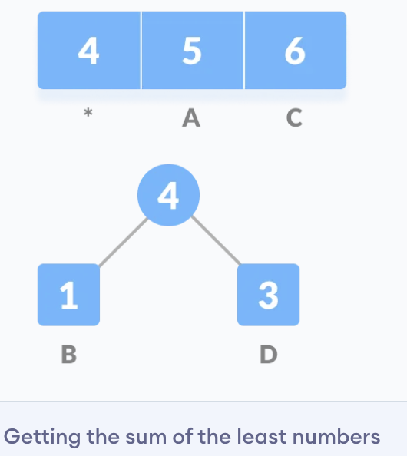

5. Remove these two minimum frequencies from Q and add the sum into the list of frequencies (* denote the internal nodes in the figure above).

6. Insert node z into the tree.

7. Repeat steps 3 to 5 for all the characters.

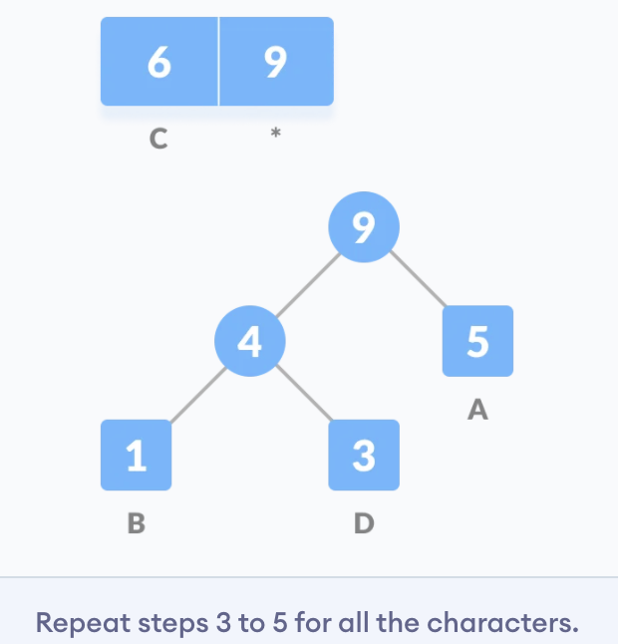

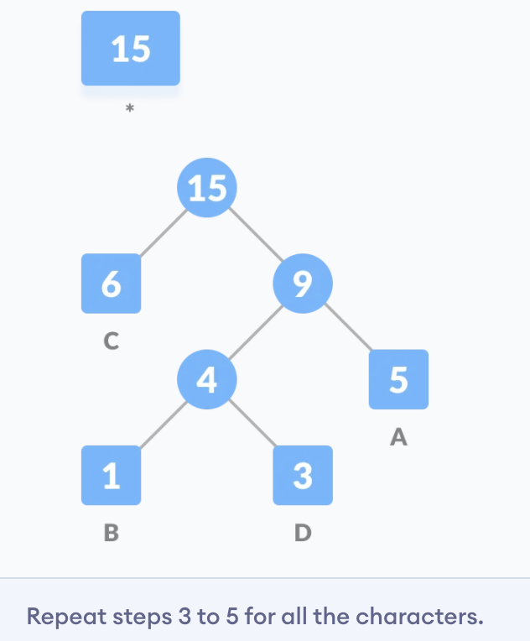

8. For each non-leaf node, assign 0 to the left edge and 1 to the right edge.

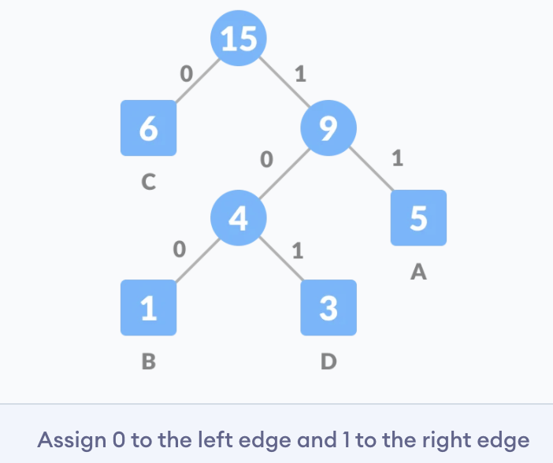

For sending the above string over a network, we have to send the tree as well as the above compressed-code. The total size is given by the table below.

|  |  |  |  |
| --- | --- | --- | --- |
| **Character** | **Frequency** | **Code** | **Size** |
| A | 5 | 11 | 5*2 = 10 |
| B | 1 | 100 | 1*3 = 3 |
| C | 6 | 0 | 6*1 = 6 |
| D | 3 | 101 | 3*3 = 9 |
| 4 * 8 = 32 bits | 15 bits |  | 28 bits |

Without encoding, the total size of the string was 120 bits. After encoding the size is reduced to 32 + 15 + 28 = 75.

**Decoding the code**

For decoding the code, we can take the code and traverse through the tree to find the character.

Let 101 is to be decoded, we can traverse from the root as in the figure below.

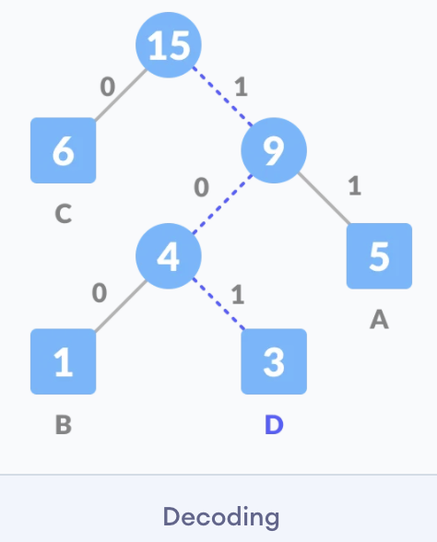

**Huffman Coding Complexity**

The time complexity for encoding each unique character based on its frequency is O(nlog n).

Extracting minimum frequency from the priority queue takes place 2*(n-1) times and its complexity is O(log n). Thus the overall complexity is O(nlog n).

**Dynamic Programming**

Dynamic Programming is a technique in computer programming that helps to efficiently solve a class of problems that have overlapping subproblems and optimal substructure property.

If any problem can be divided into subproblems, which in turn are divided into smaller subproblems, and if there are overlapping among these subproblems, then the solutions to these subproblems can be saved for future reference. In this way, efficiency of the CPU can be enhanced. This method of solving a solution is referred to as dynamic programming.

Such problems involve repeatedly calculating the value of the same subproblems to find the optimum solution.

**Dynamic Programming Example**

Let's find the fibonacci sequence upto 5th term. A fibonacci series is the sequence of numbers in which each number is the sum of the two preceding ones. For example, 0,1,1, 2, 3. Here, each number is the sum of the two preceding numbers.

**Algorithm**

Let n be the number of terms.

1. If n <= 1, return 1.

2. Else, return the sum of two preceding numbers.

We are calculating the fibonacci sequence up to the 5th term.

1. The first term is 0.
2. The second term is 1.
3. The third term is sum of 0 (from step 1) and 1(from step 2), which is 1.
4. The fourth term is the sum of the third term (from step 3) and second term (from step 2) i.e. 1 + 1 = 2.
5. The fifth term is the sum of the fourth term (from step 4) and third term (from step 3) i.e. 2 + 1 = 3.

Hence, we have the sequence 0,1,1, 2, 3. Here, we have used the results of the previous steps as shown below. This is **called a dynamic programming approach.**

F(0) = 0

F(1) = 1

F(2) = F(1) + F(0)

F(3) = F(2) + F(1)

F(4) = F(3) + F(2)

**How Dynamic Programming Works**

Dynamic programming works by storing the result of subproblems so that when their solutions are required, they are at hand and we do not need to recalculate them.

This technique of storing the value of subproblems is called **memoization**. By saving the values in the array, we save time for computations of sub-problems we have already come across.

var m = map(0 → 0, 1 → 1)

function fib(n)

if key n is not in map m

m[n] = fib(n − 1) + fib(n − 2)

return m[n]

Dynamic programming by memoization is a top-down approach to dynamic programming. By reversing the direction in which the algorithm works i.e. by starting from the base case and working towards the solution, we can also implement dynamic programming in a bottom-up manner.

function fib(n)

if n = 0

return 0

else

var prevFib = 0, currFib = 1

repeat n − 1 times

var newFib = prevFib + currFib

prevFib = currFib

currFib = newFib

return currentFib

**Recursion vs Dynamic Programming**

Dynamic programming is mostly applied to recursive algorithms. This is not a coincidence, most optimization problems require recursion and dynamic programming is used for optimization.

But not all problems that use recursion can use Dynamic Programming. Unless there is a presence of overlapping subproblems like in the fibonacci sequence problem, a recursion can only reach the solution using a divide and conquer approach.

That is the reason why a recursive algorithm like Merge Sort cannot use Dynamic Programming, because the subproblems are not overlapping in any way.

**Greedy Algorithms vs Dynamic Programming**

Greedy Algorithms are similar to dynamic programming in the sense that they are both tools for optimization.

However, greedy algorithms look for locally optimum solutions or in other words, a greedy choice, in the hopes of finding a global optimum. Hence greedy algorithms can make a guess that looks optimum at the time but becomes costly down the line and do not guarantee a globally optimum.

Dynamic programming, on the other hand, finds the optimal solution to subproblems and then makes an informed choice to combine the results of those subproblems to find the most optimum solution.

**Different Types of Greedy Algorithm**

* Longest Common Subsequence
* Floyd-Warshall Algorithm

**Floyd-Warshall Algorithm**

Floyd-Warshall Algorithm is an algorithm for finding the shortest path between all the pairs of vertices in a weighted graph. This algorithm works for both the directed and undirected weighted graphs. But, it does not work for the graphs with negative cycles (where the sum of the edges in a cycle is negative).

**Note:** A weighted graph is a graph in which each edge has a numerical value associated with it.

**Floyd-Warhshall algorithm is also called as Floyd's algorithm, Roy-Floyd algorithm, Roy-Warshall algorithm, or WFI algorithm.**

This **algorithm follows the dynamic programming** approach to find the shortest paths.

**How Floyd-Warshall Algorithm Works?**

Let the given graph be:

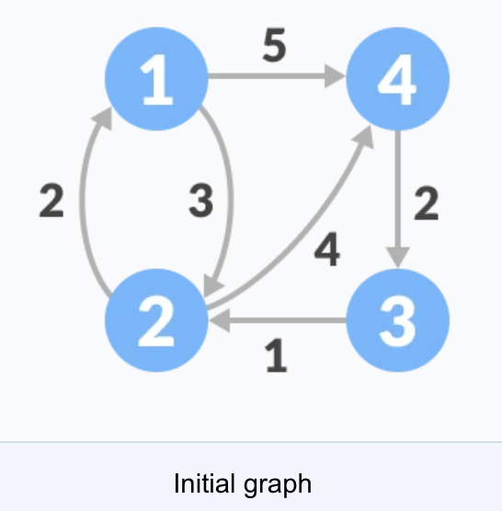

Follow the steps below to find the shortest path between all the pairs of vertices.

1. Create a matrix A0 of dimension n*n where n is the number of vertices. The row and the column are indexed as i and j respectively. i and j are the vertices of the graph.

Each cell A[i][j] is filled with the distance from the ith vertex to the jth vertex. If there is no path from ith vertex to jth vertex, the cell is left as infinity.

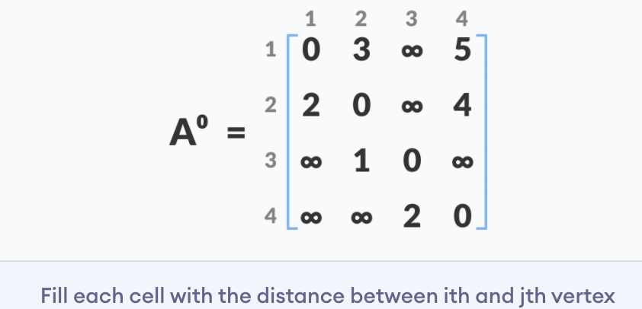

2. Now, create a matrix A1 using matrix A0. The elements in the first column and the first row are left as they are. The remaining cells are filled in the following way.

Let k be the intermediate vertex in the shortest path from source to destination. In this step, k is the first vertex. A[i][j] is filled with (A[i][k] + A[k][j]) if (A[i][j] > A[i][k] + A[k][j]).

That is, if the direct distance from the source to the destination is greater than the path through the vertex k, then the cell is filled with A[i][k] + A[k][j].

In this step, k is vertex 1. We calculate the distance from source vertex to destination vertex through this vertex k.

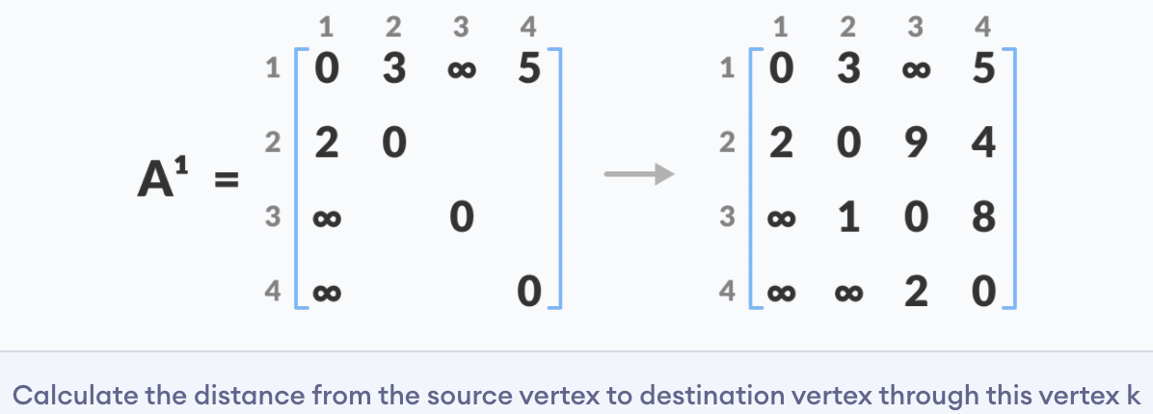

For example: For A1[2, 4], the direct distance from vertex 2 to 4 is 4 and the sum of the distance from vertex 2 to 4 through vertex (ie. from vertex 2 to 1 and from vertex 1 to 4) is 7. Since 4 < 7, A0[2, 4] is filled with 4.

3. Similarly, A2 is created using A1. The elements in the second column and the second row are left as they are.

In this step, k is the second vertex (i.e. vertex 2). The remaining steps are the same as in **step 2.**

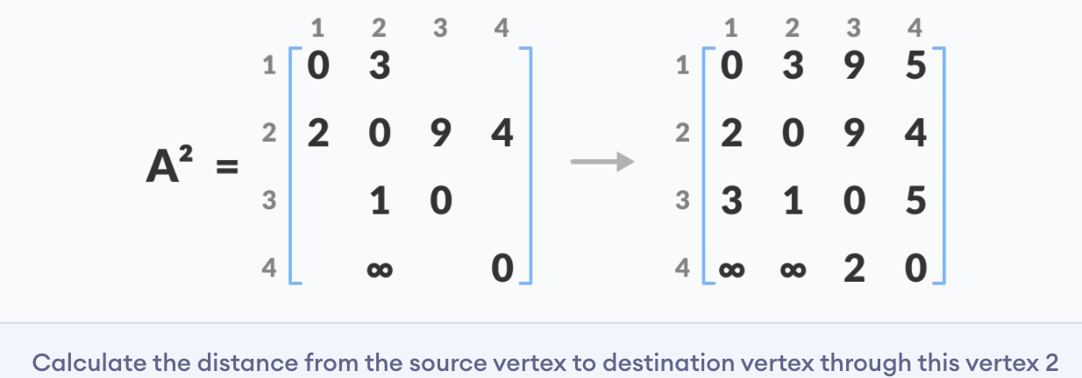

4. Similarly, A3 and A4 is also created.

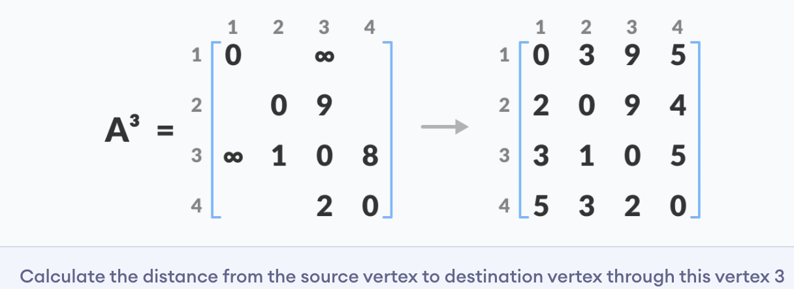

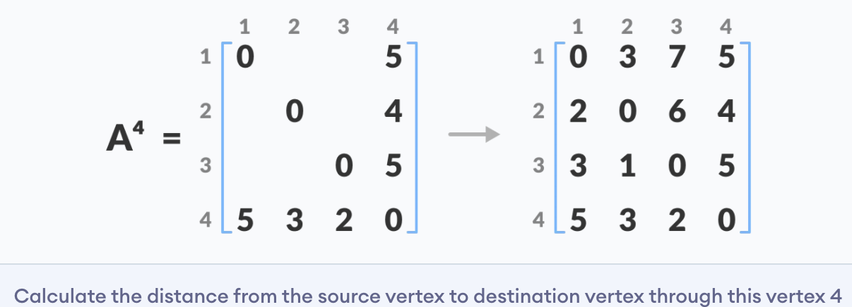

5. A4 gives the shortest path between each pair of vertices.

**Floyd Warshall Algorithm Time Complexity**

There are three loops. Each loop has constant complexities. So, the time complexity of the Floyd-Warshall algorithm is O(n3).

**Space Complexity**

The space complexity of the Floyd-Warshall algorithm is O(n2).

**Longest Common Subsequence**

**The longest common subsequence (LCS)** is defined as the longest subsequence that is common to all the given sequences, provided that the elements of the subsequence are not required to occupy consecutive positions within the original sequences.

If S1 and S2 are the two given sequences then, Z is the common subsequence of S1 and S2 if Z is a subsequence of both S1 and S2. Furthermore, Z must be a **strictly increasing sequence** of the indices of both S1 and S2.

In a strictly increasing sequence, the indices of the elements chosen from the original sequences must be in ascending order in Z.

If

S1 = {B, C, D, A, A, C, D}

Then, {A, D, B} cannot be a subsequence of S1 as the order of the elements is not the same (ie. not strictly increasing sequence).

Let us understand LCS with an example.

If

S1 = {B, C, D, A, A, C, D}

S2 = {A, C, D, B, A, C}

Then, common subsequences are {B, C}, {C, D, A, C}, {D, A, C}, {A, A, C}, {A, C}, {C, D}, ...

Among these subsequences, {C, D, A, C} is the longest common subsequence. We are going to find this longest common subsequence using dynamic programming.

Before proceeding further, if you do not already know about dynamic programming, please go through dynamic programming.

**Using Dynamic Programming to find the LCS**

Let us take two sequences:

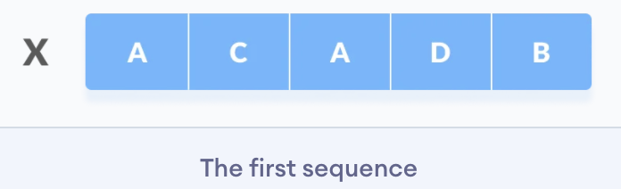 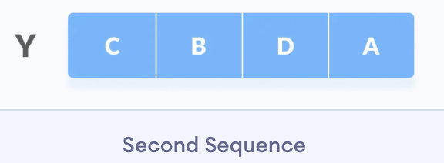

The following steps are followed for finding the longest common subsequence.

1. Create a table of dimension n+1*m+1 where n and m are the lengths of X and Y respectively. The first row and the first column are filled with zeros.

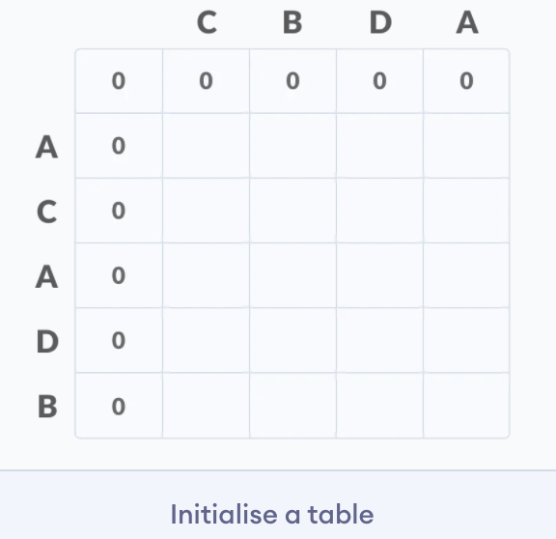

2. Fill each cell of the table using the following logic.

3. If the character correspoding to the current row and current column are matching, then fill the current cell by adding one to the diagonal element. Point an arrow to the diagonal cell.

4. Else take the maximum value from the previous column and previous row element for filling the current cell. Point an arrow to the cell with maximum value. If they are equal, point to any of them.

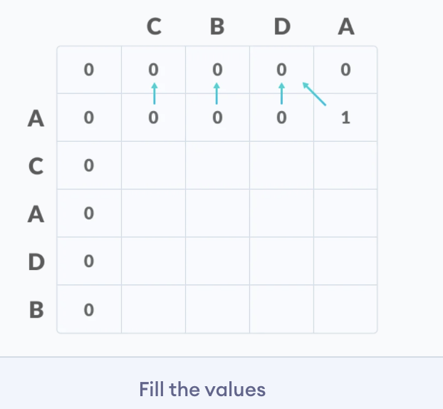

5. **Step 2** is repeated until the table is filled.

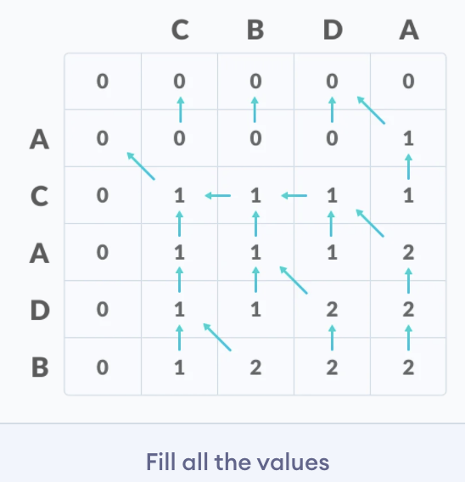

6. The value in the last row and the last column is the length of the longest common subsequence.

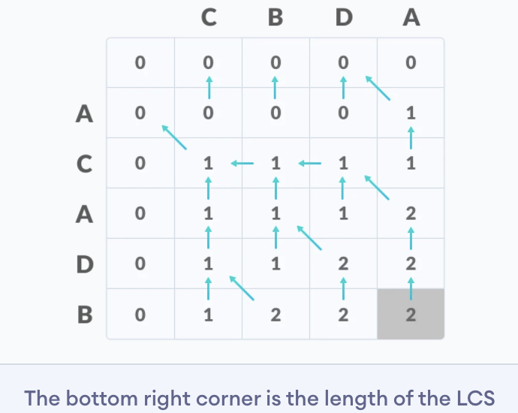

7. In order to find the longest common subsequence, start from the last element and follow the direction of the arrow. The elements corresponding to () symbol form the longest common subsequence.

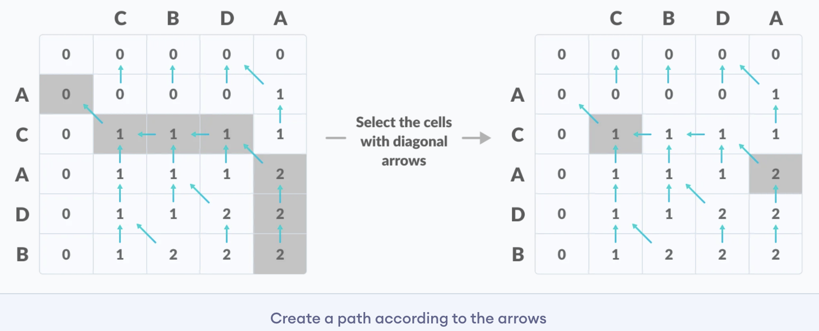

Thus, the longest common subsequence is CD.

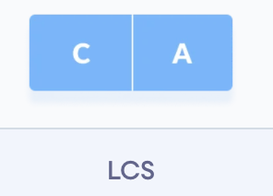

**How is a dynamic programming algorithm more efficient than the recursive algorithm while solving an LCS problem?**

The method of dynamic programming reduces the number of function calls. It stores the result of each function call so that it can be used in future calls without the need for redundant calls.

In the above dynamic algorithm, the results obtained from each comparison between elements of X and the elements of Y are stored in a table so that they can be used in future computations.

So, the time taken by a dynamic approach is the time taken to fill the table (ie. O(mn)). Whereas, the recursion algorithm has the complexity of 2max(m, n).

Window Sliding Technique:

Bellman-Ford algorithm.